**MODULE I**

**Introduction and Applications of AI**

In this module, you will explore the fundamentals of Artificial Intelligence (AI) and its growing impact across industries. You will learn to distinguish between AI and augmented intelligence and examine the evolution from traditional AI to generative AI. Through practical examples, you’ll identify real-world use cases in daily life and business. You’ll also gain hands-on experience with generative AI tools and chatbot design. By the end, you’ll understand AI’s capabilities, limitations, and role in enhancing human potential.

**Learning Objectives**

* Explain the fundamental concepts and applications of artificial intelligence (AI) in various domains.
* Differentiate between artificial intelligence and augmented intelligence, highlighting their distinct roles in enhancing human capabilities.
* Apply knowledge of generative AI to identify its practical use cases across industries.
* Classify AI systems into narrow, general, and superintelligent categories based on their capabilities.
* Compare traditional AI and generative AI to understand their functional differences and evolution.
* Explain the current limitations and progress of AI in achieving general human-like intelligence.
* Identify and describe applications of AI that enhance everyday personal and professional tasks.
* Explain the role of AI in enabling the functionality of chatbots and smart assistants.
* Describe the definition, purpose, and functioning of a chatbot in digital interactions.
* Apply techniques to create and improve conversational flows in AI assistant interactions.
* Identify how AI is applied across various industries to improve processes and decision-making.
* Apply generative AI tools to perform tasks such as content creation and automation.
* Explain common use cases of AI and machine learning in routine personal and commercial activities.
* Demonstrate the ability to use generative AI tools to generate relevant outputs from input prompts.

**Welcome**

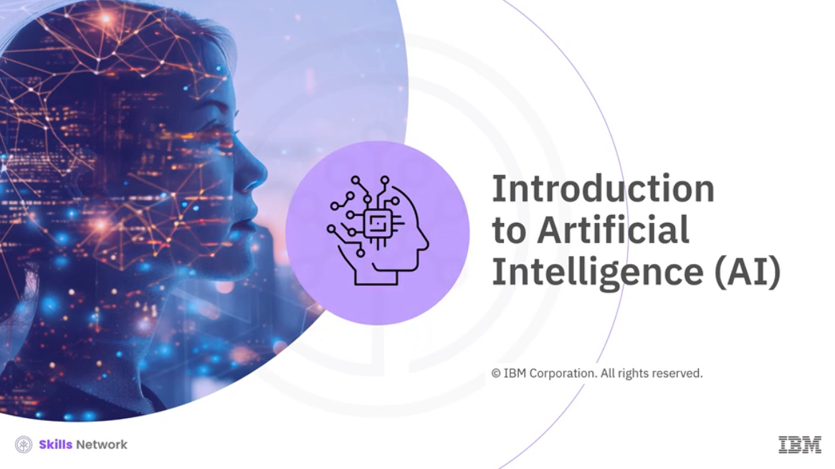

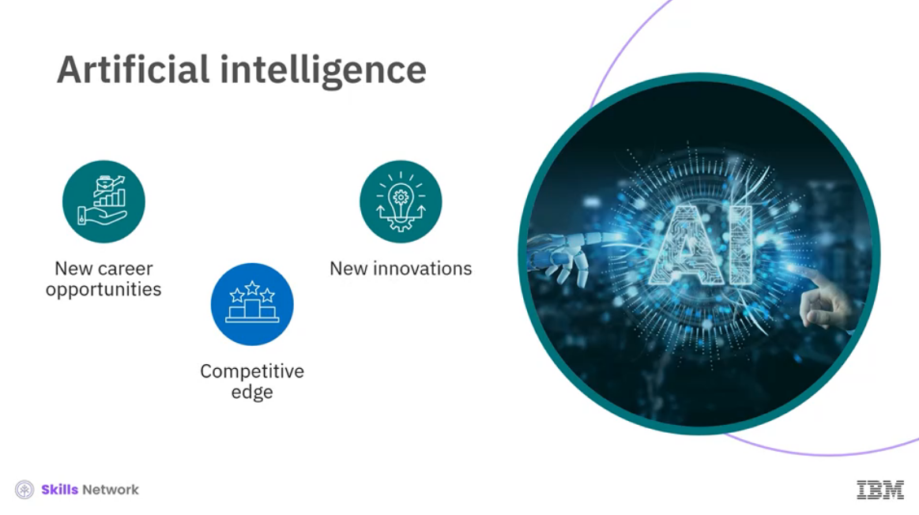

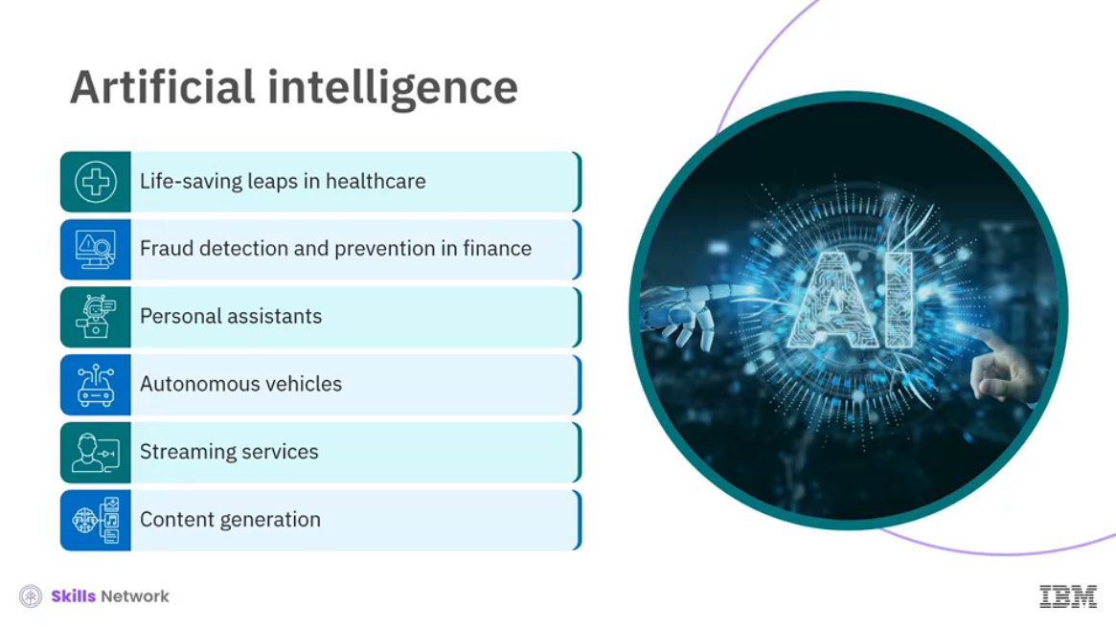

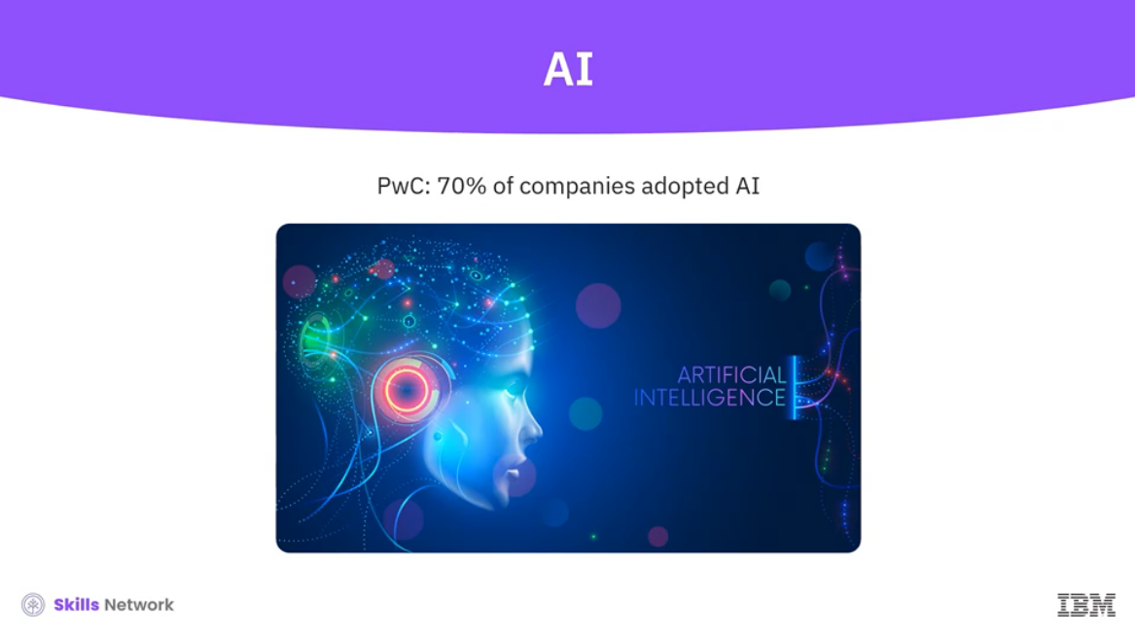

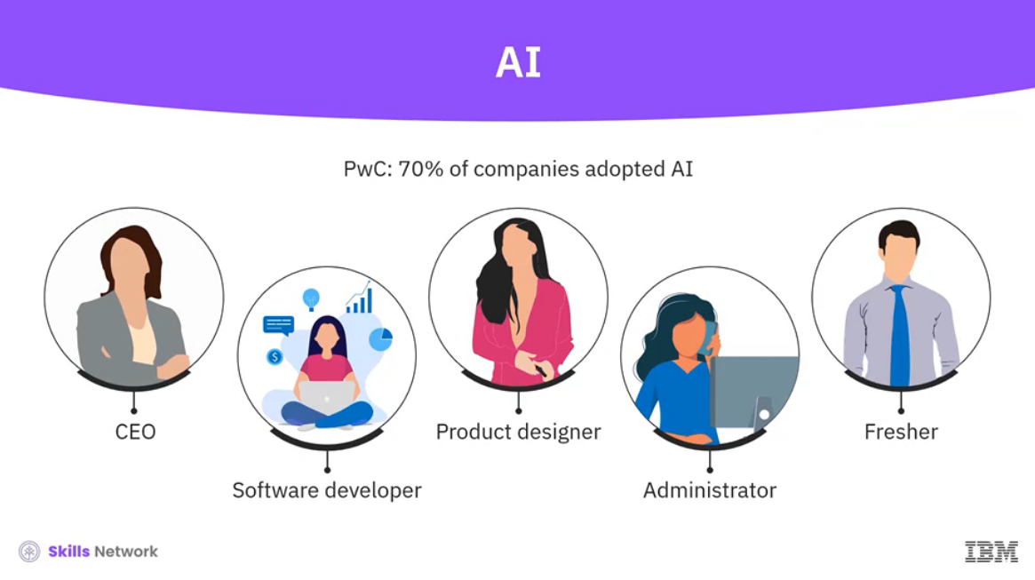

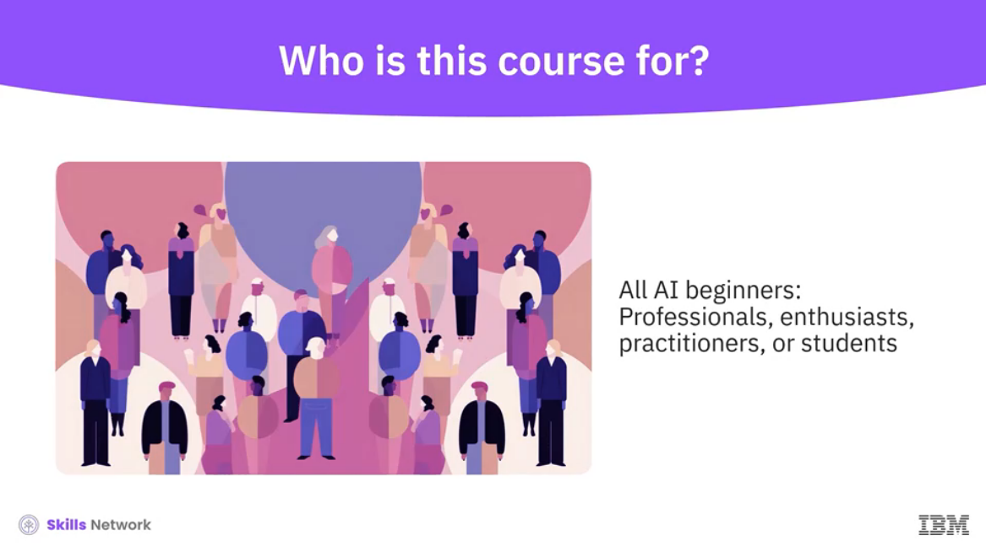

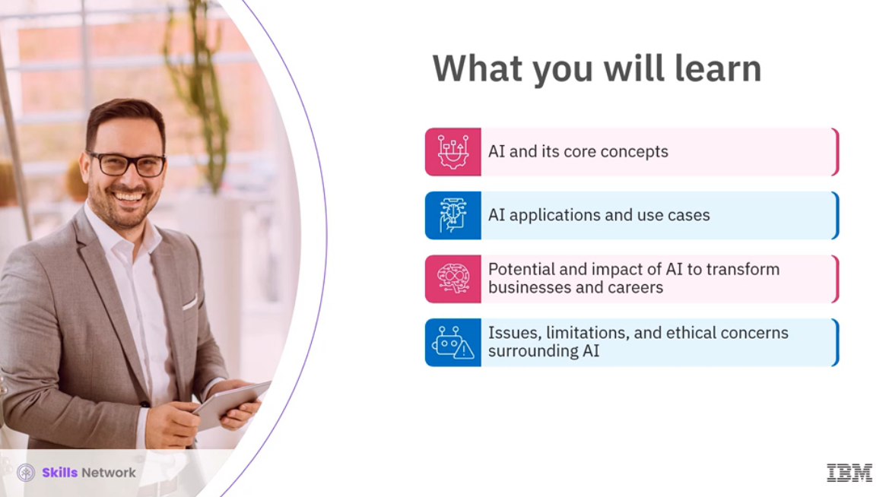

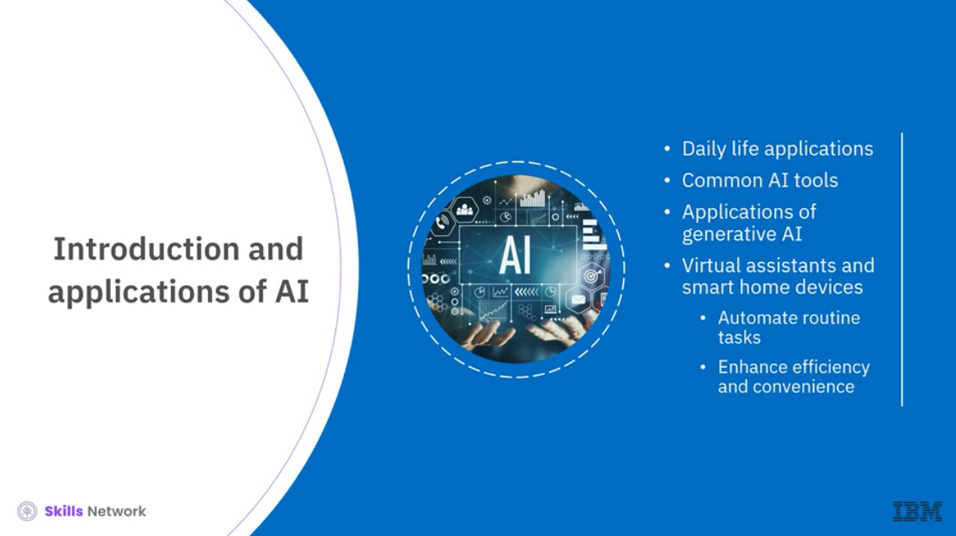

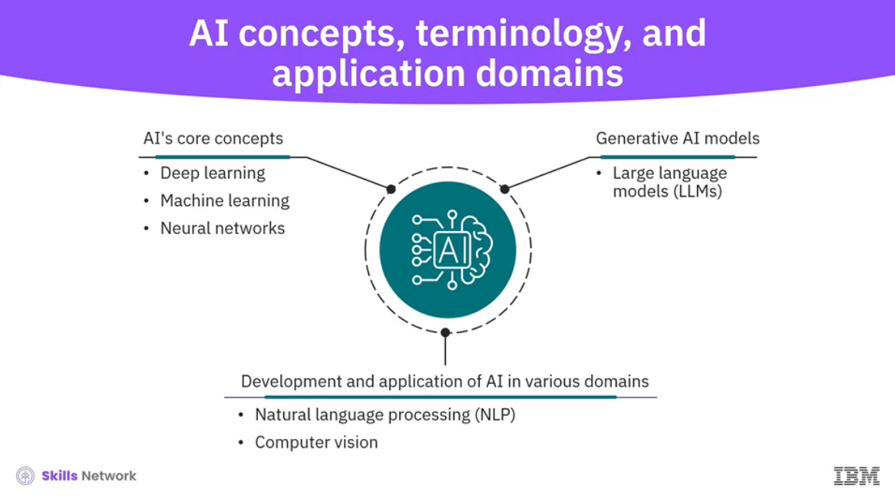

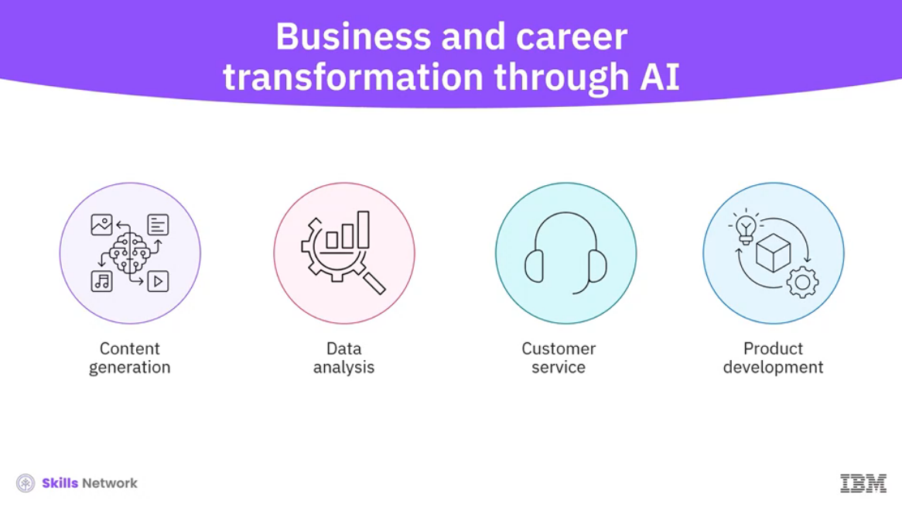

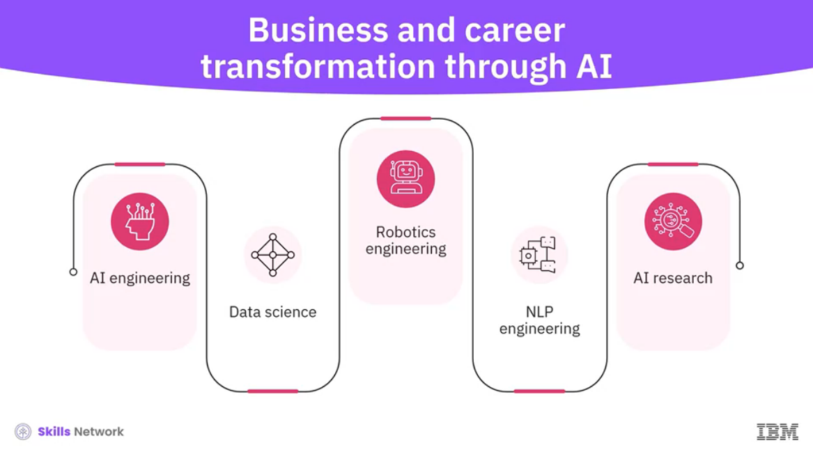

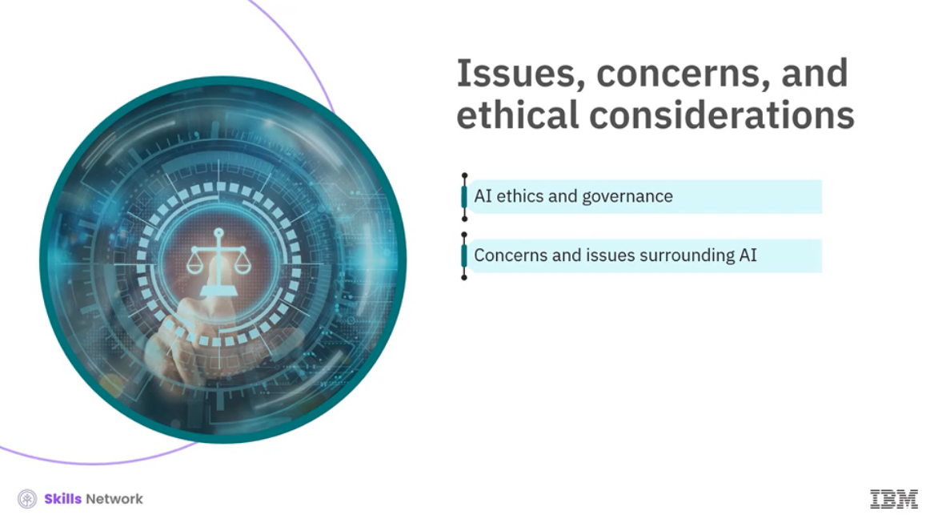

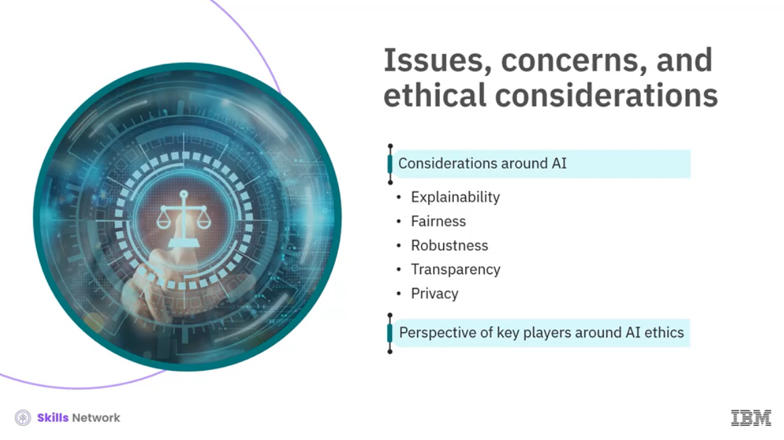

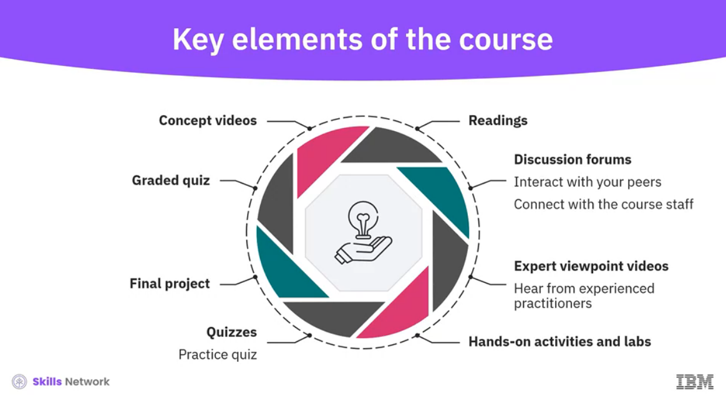

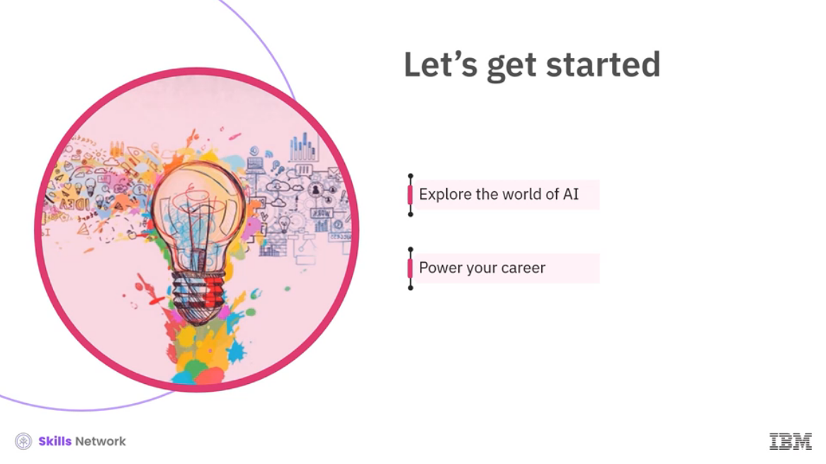

______________________________________________________________________________

Course Overview

Hello, and welcome to the **Introduction to Artificial Intelligence (AI)** course!

In this course, you will uncover the basics of AI, explore its diverse applications, and understand how it is transforming our lives.

This course covers core AI concepts, including deep learning, machine learning, and neural networks. You’ll examine generative AI models, including large language models (LLMs) and their capabilities. Furthermore, you’ll examine AI’s application across domains such as natural language processing (NLP), computer vision, and robotics, uncovering how these advancements drive innovation and use cases.

This course discovers the transformative impact of AI, including generative AI, on businesses. Additionally, you’ll understand how AI can revolutionize your work and environment and what career opportunities are arising through AI.

Finally, the course explores AI ethics and governance and prevalent concerns and issues surrounding the AI landscape.

This course is part of the [**IBM AI Developer Professional Certificate**](https://www.coursera.org/professional-certificates/applied-artifical-intelligence-ibm-watson-ai), which is targeted to individuals who want to launch their career in AI and learn to build AI-powered chatbots and apps. No prior AI or programming experience is required for this Professional Certificate.

**Prerequisites**

There are no specific prerequisites for this course. This course is suitable for everyone, including students, professionals, and enthusiasts interested in learning about the fundamentals of AI.

**Course outline**

This course is divided into four modules. You can complete each module at your own pace, but it's recommended to set a goal of completing at least one module per week.

**Module 1: Introduction and Applications of AI**

This module is focused on the fundamentals of AI. You will learn the definition of AI and the basics of generative AI. You will explore the impact, applications, and use cases of AI and how it is transforming our lives. Additionally, you will discover common tools and applications of generative AI. You will learn about AI agents and smart assistants and their common use cases. Finally, you will examine how AI is reshaping various industries and sectors.

**Module 2: AI Concepts, Terminology, and Application Domains**

This module discusses the core concepts and techniques of AI. You will learn about deep learning, machine learning, and neural networks. You'll explore generative AI models, including large language models (LLMs), and their capabilities. Additionally, you'll explore the development and application of AI in various domains like natural language processing (NLP), computer vision, and robotics, discovering how advancements in these areas drive diverse innovations and use cases.

**Module 3: Business and Career Transformation through AI**

This module explores the impact of AI, including generative AI, on business transformation. You'll learn about the benefits AI offers to companies and delve into various use cases. Additionally, you'll discover how AI can revolutionize your work and work environment. The module also covers career opportunities in the AI domain.

You'll examine key considerations for organizations looking to adopt AI and learn different frameworks and approaches used for AI implementation. This includes an in-depth look at IBM's AI Ladder framework.

**Module 4: AI: Issues, Concerns, and Ethical Considerations Around AI**

This module focuses on AI ethics and governance and addresses prevalent concerns and issues surrounding the AI landscape. In this module, you’ll learn about the fundamental principles of AI ethics and how to implement them. The module also discusses the specific ethical considerations related to generative AI. You will also learn how AI ethics are enforced through governance and regulations.

**Tools/software used**

In this course, you will use the free version or trials of various generative AI tools (such as ChatGPT, Google Gemini, or Microsoft Copilot) to learn various concepts. Paid versions are not required to complete this course. If you decide to upgrade to a paid version, you will be responsible for any charges you may incur.

Congratulations on taking the first step toward building your skills in generative AI for a career in AI and emerging technologies.

Enjoy the journey!

______________________________________________________________________________

**Introducing AI**

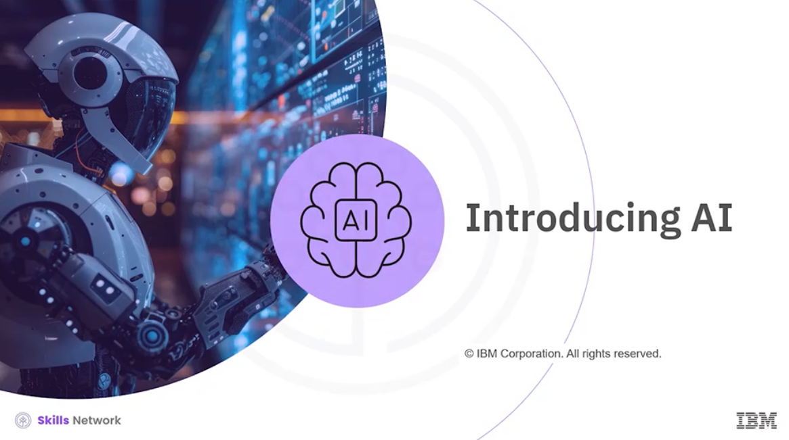

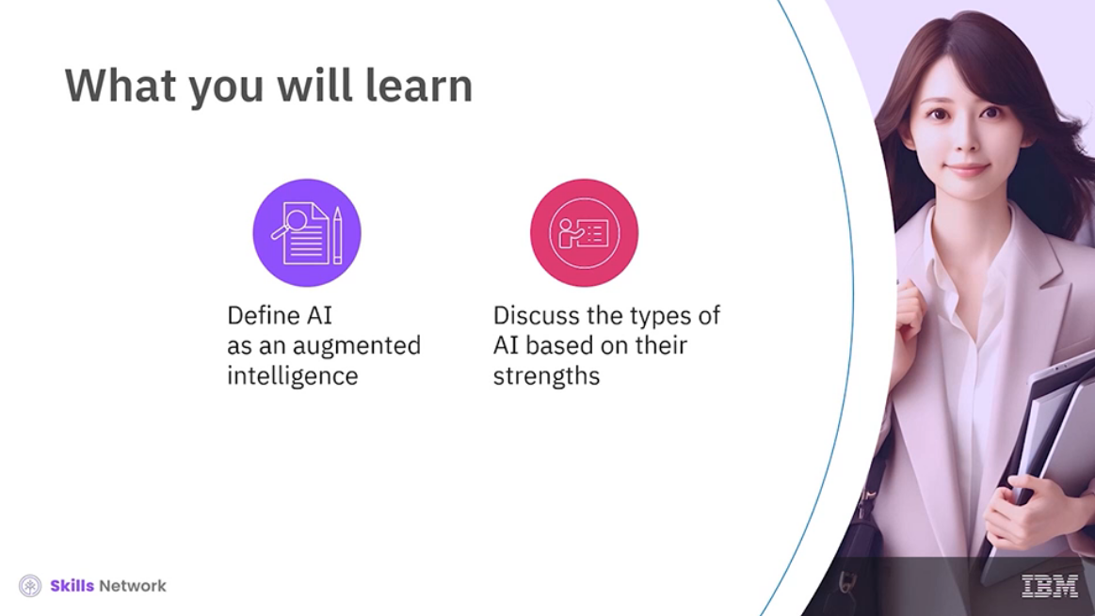

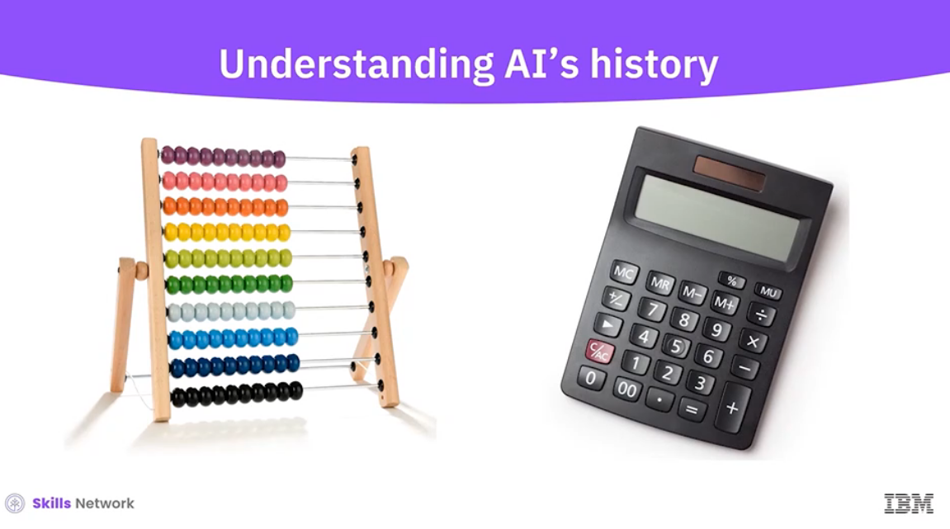

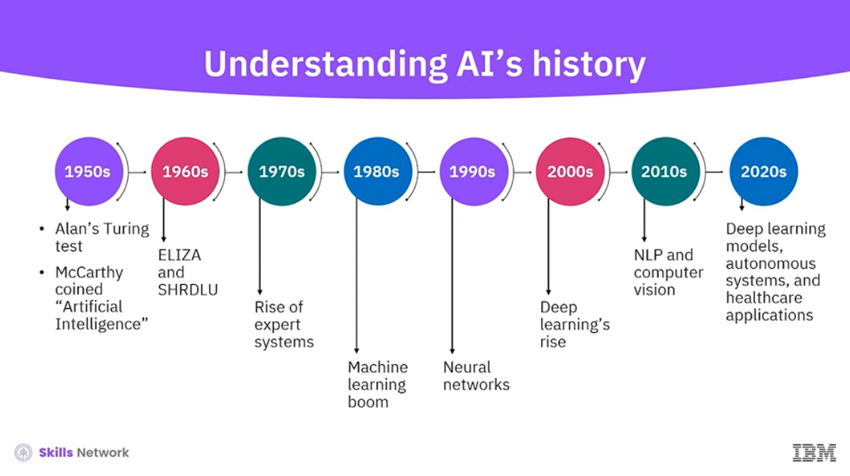

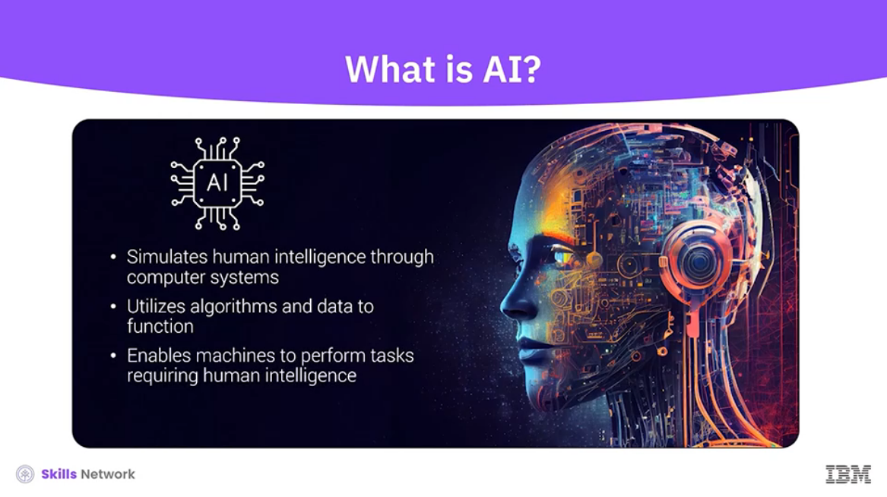

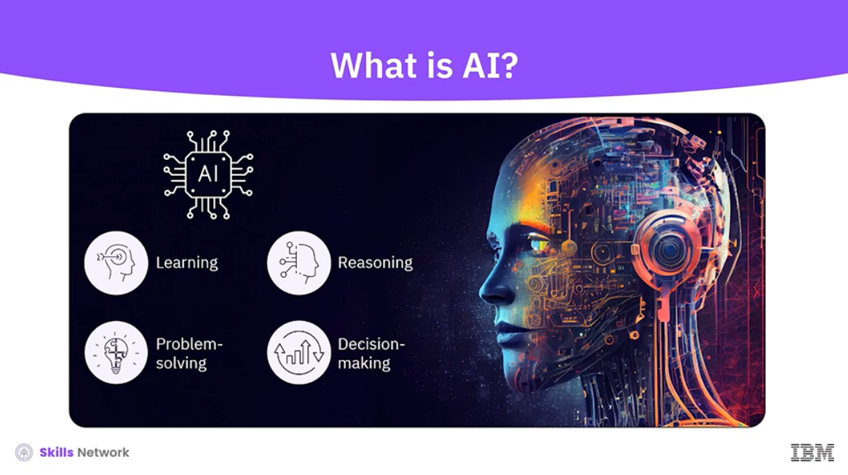

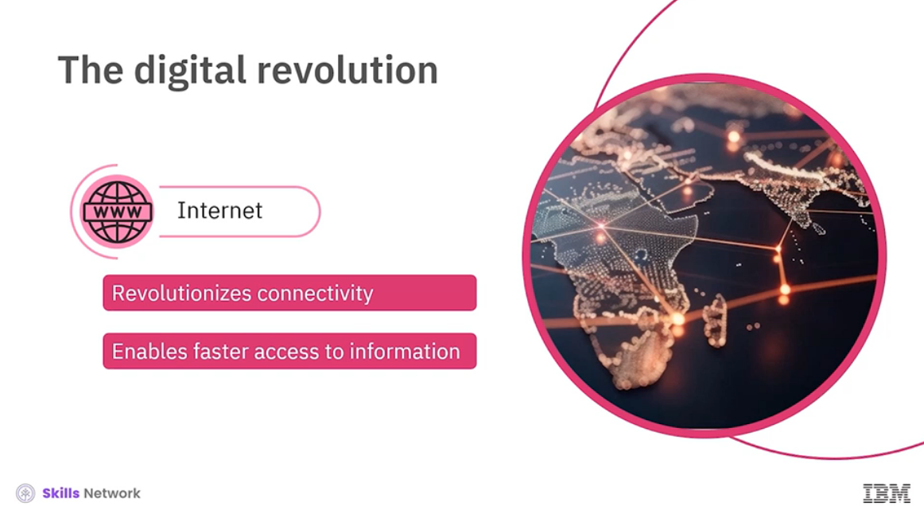

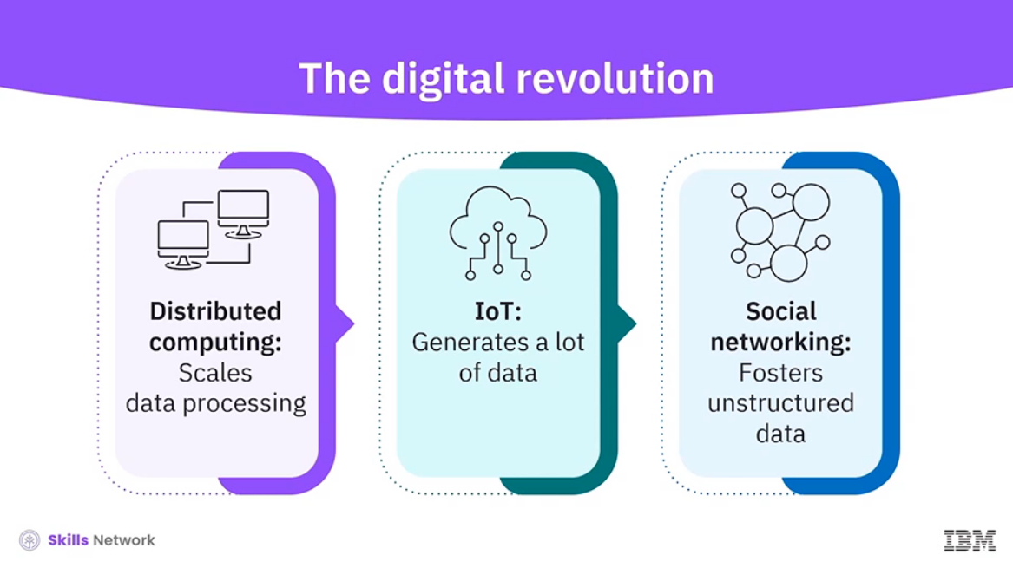

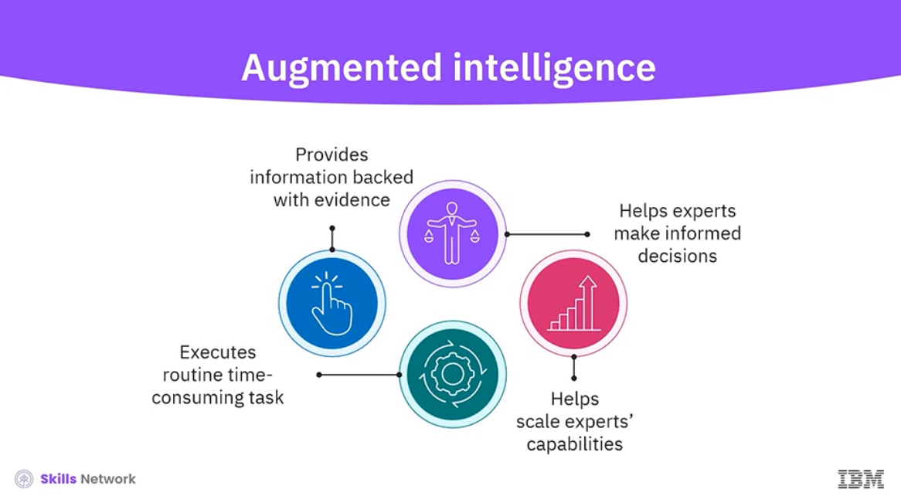

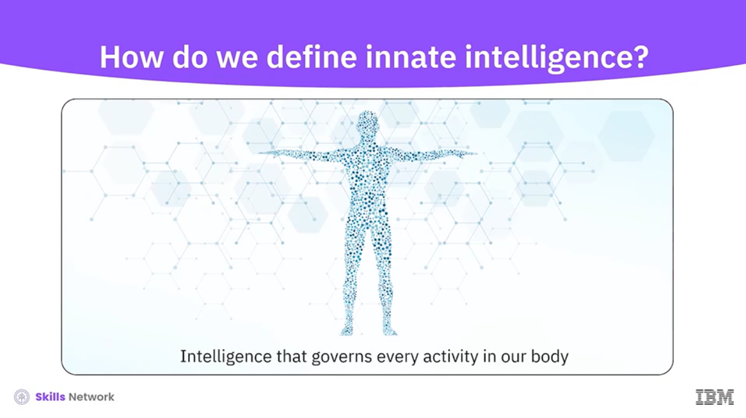

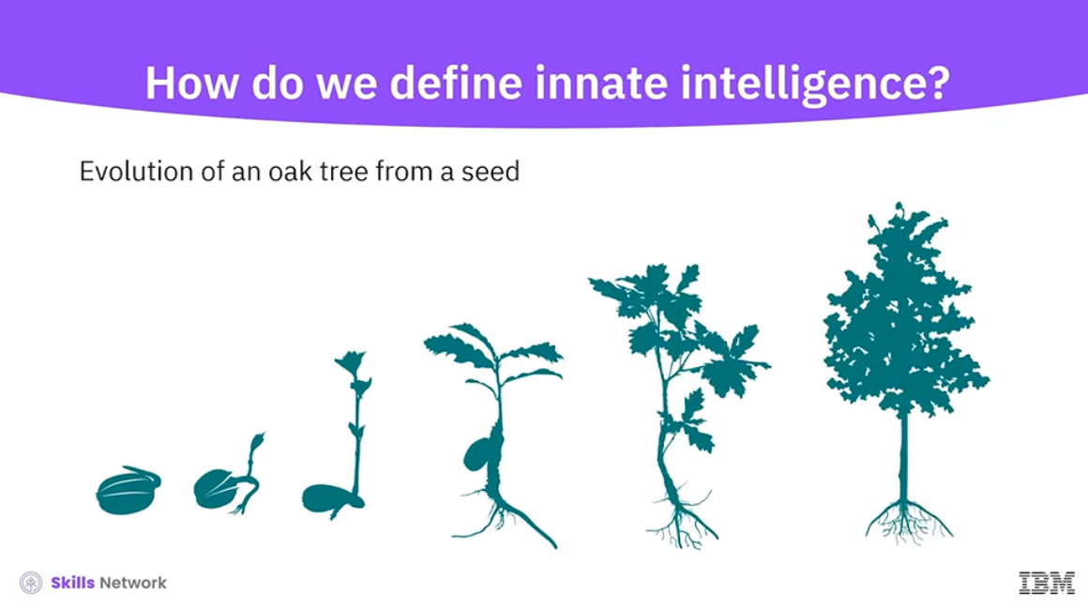

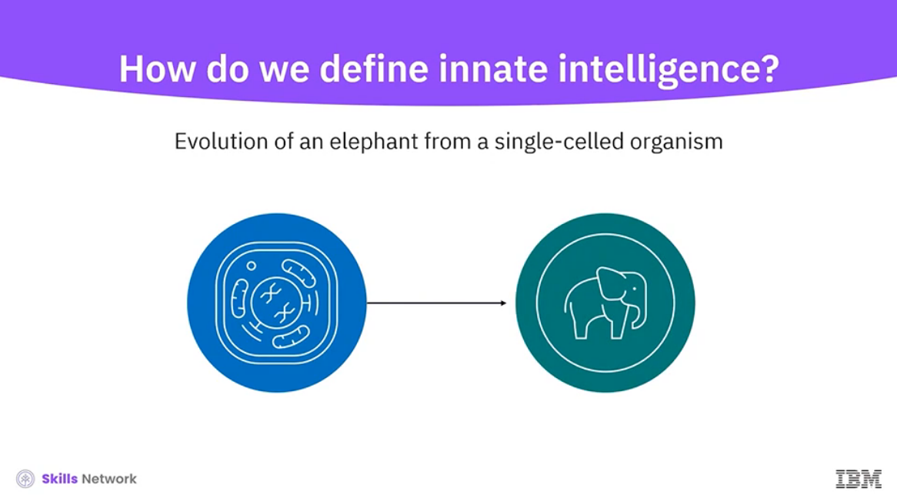

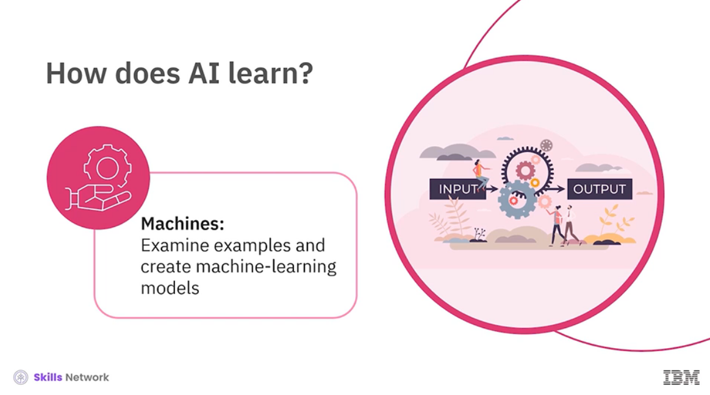

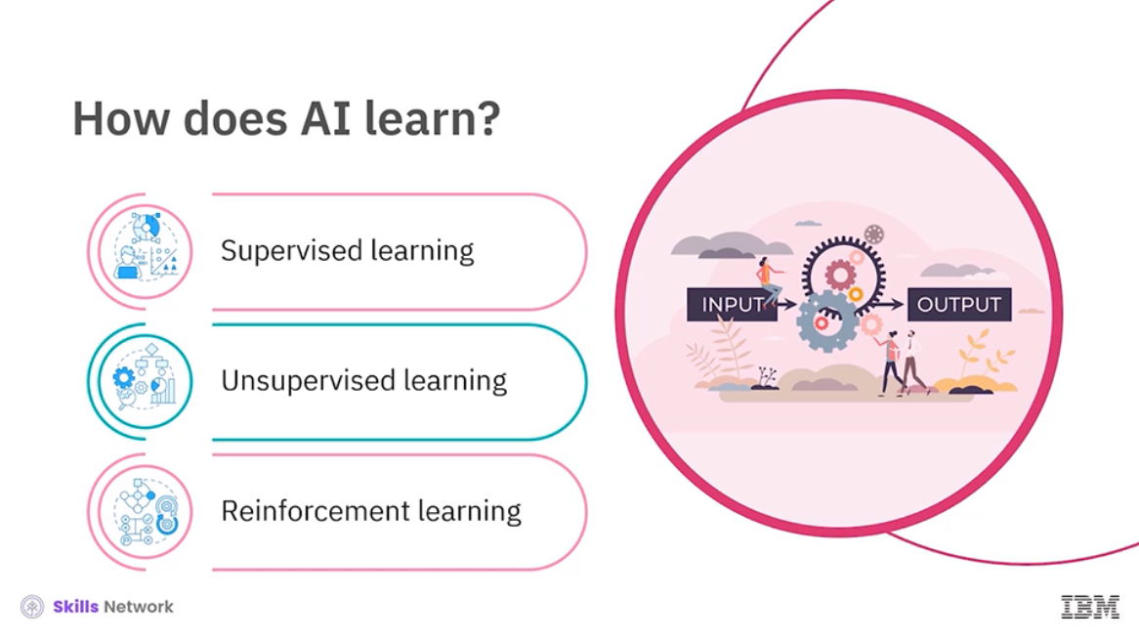

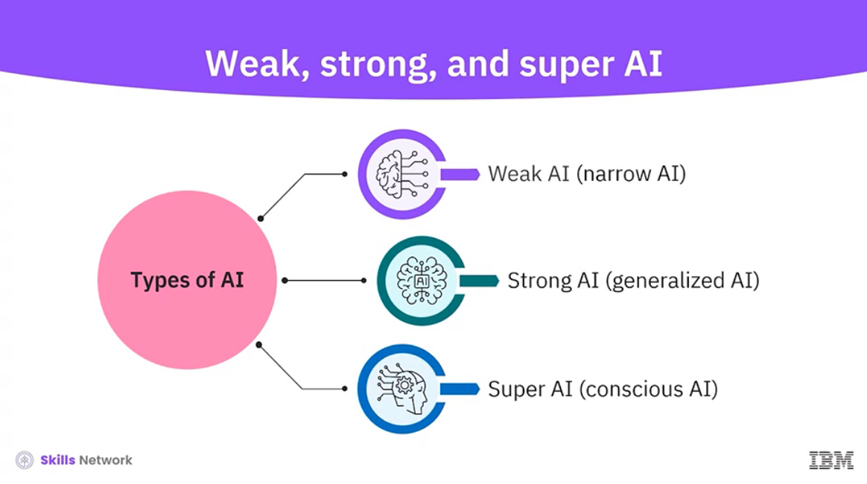

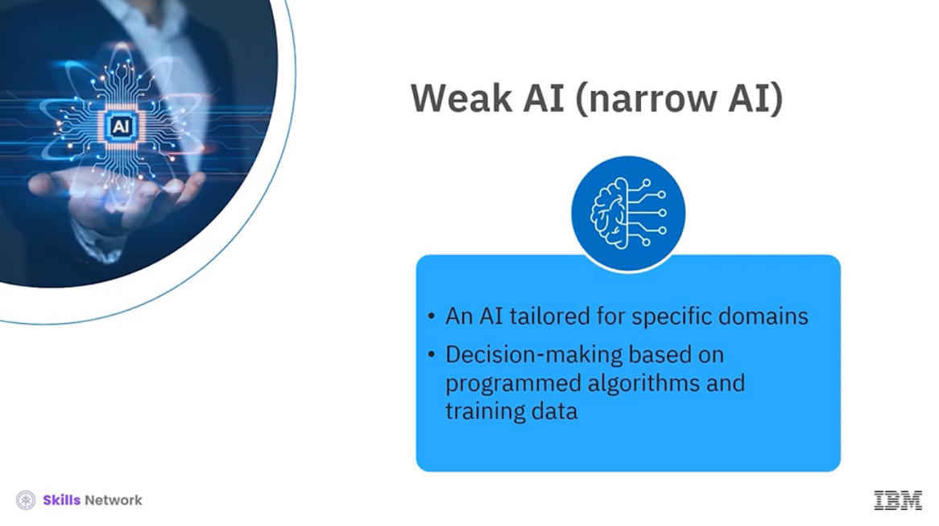

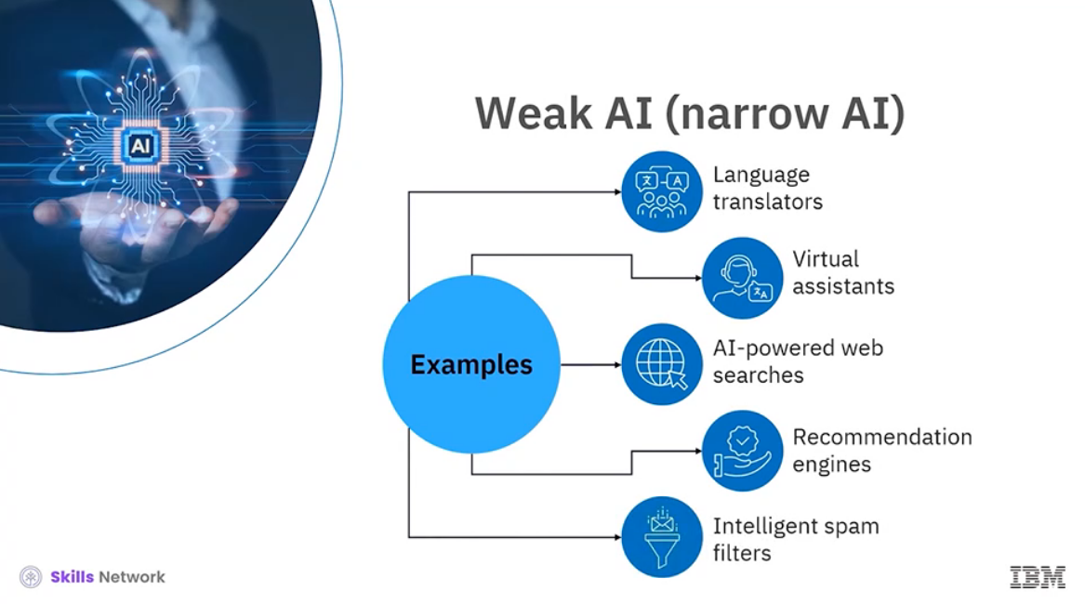

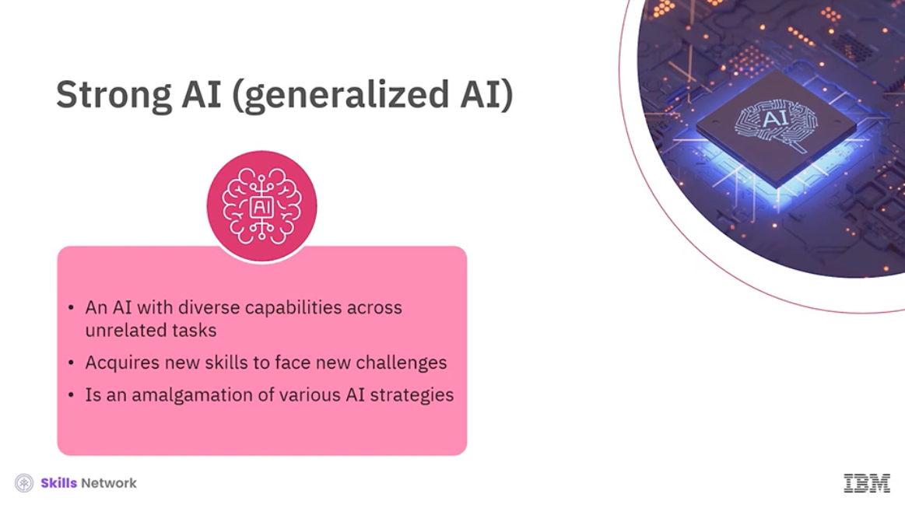

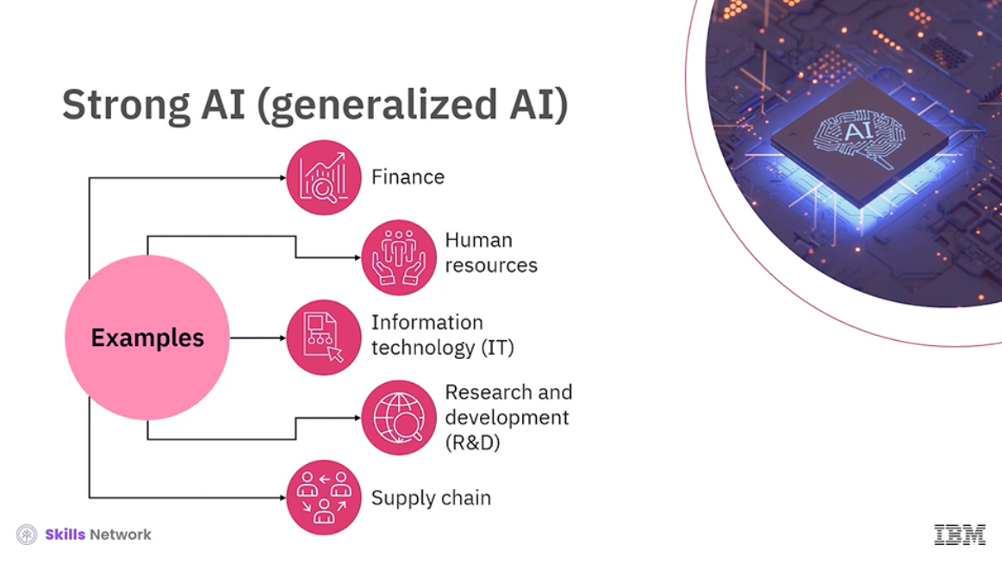

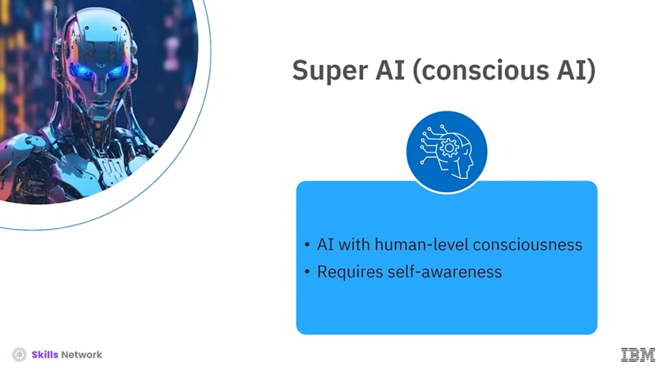

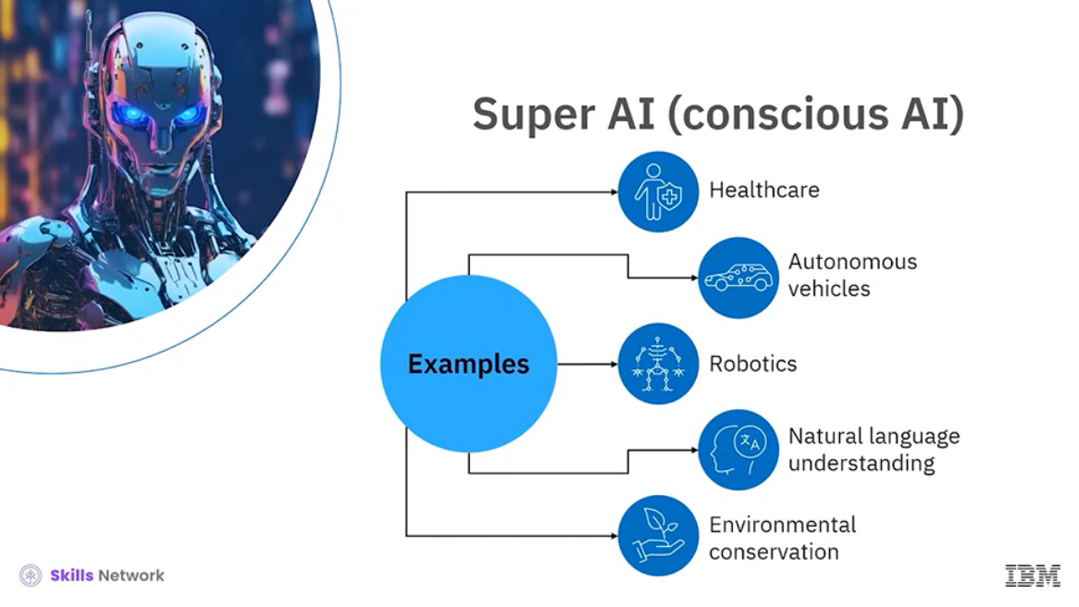

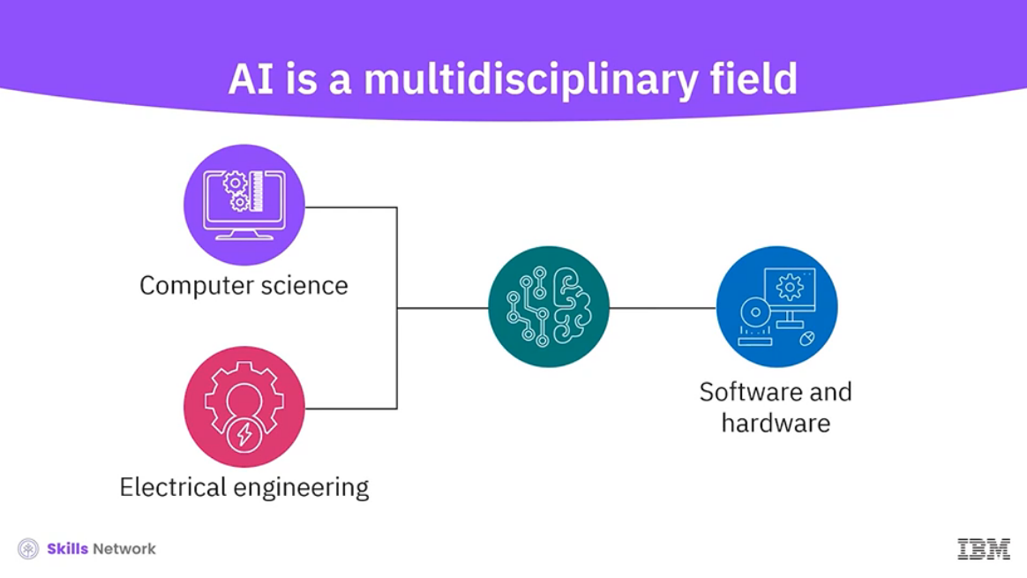

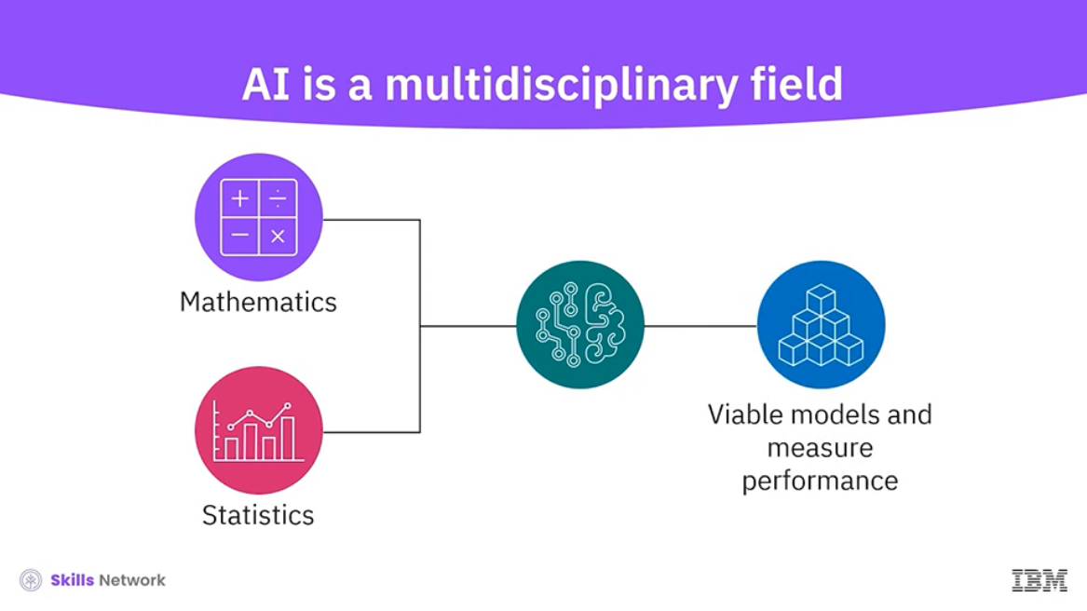

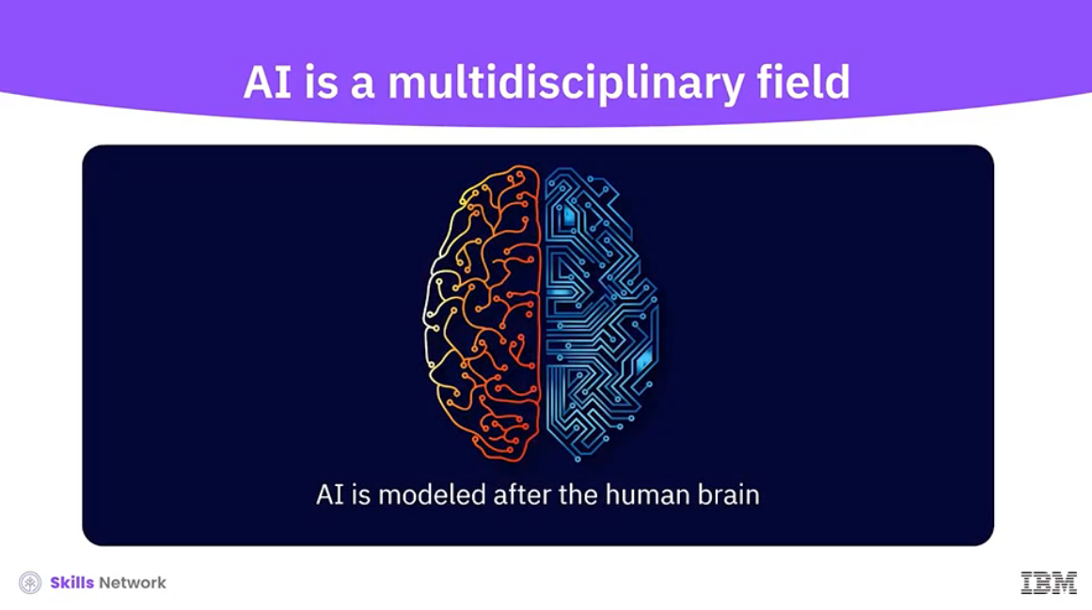

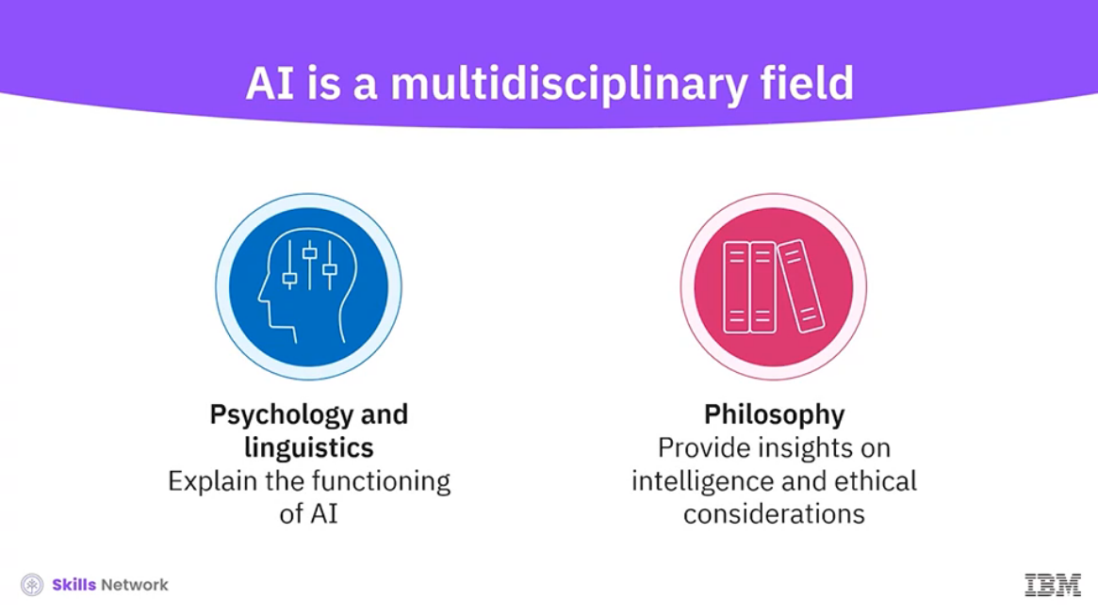

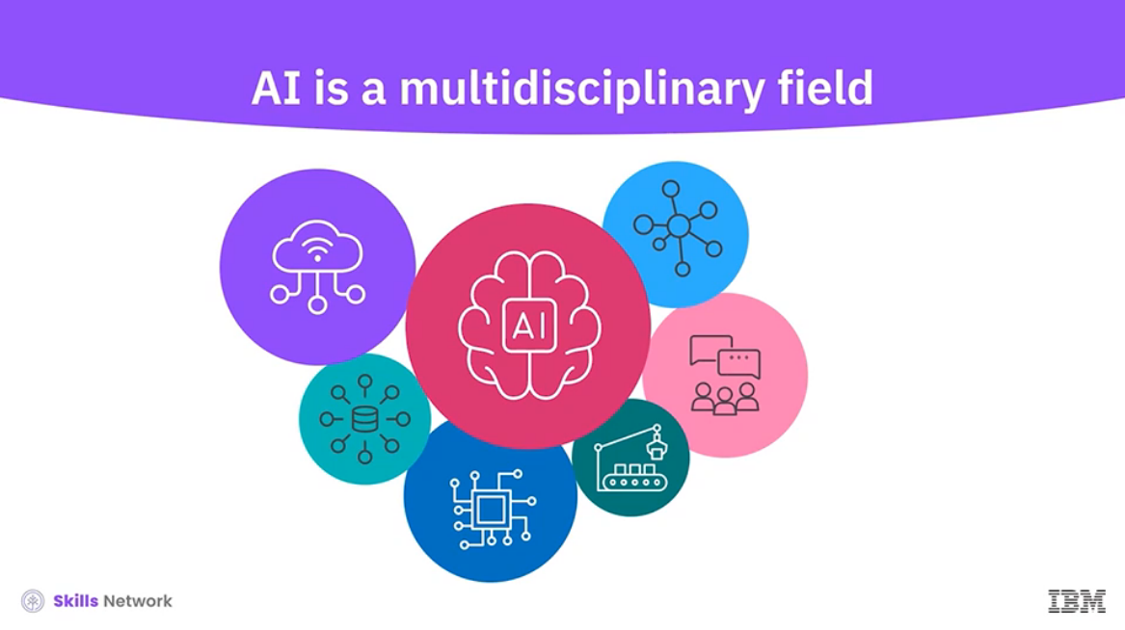

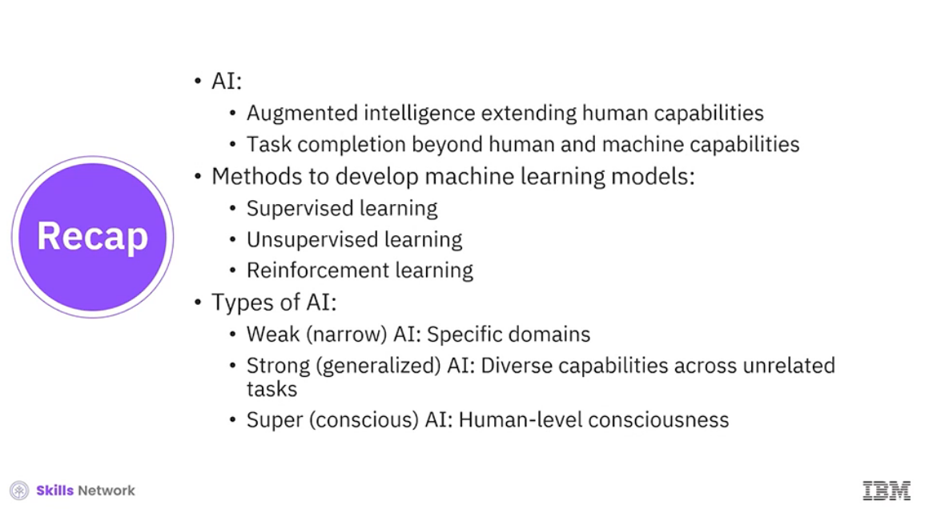

______________________________________________________________________________

**Artificial Intelligence vs. Augmented Intelligence**

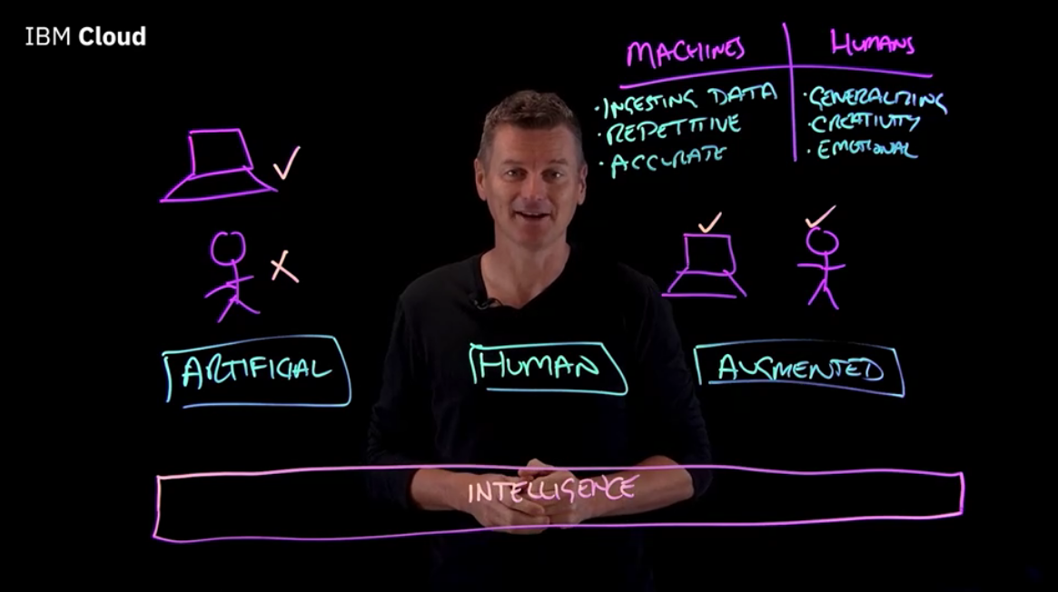

______________________________________________________________________________

**Introducing Generative AI and its Use Cases**

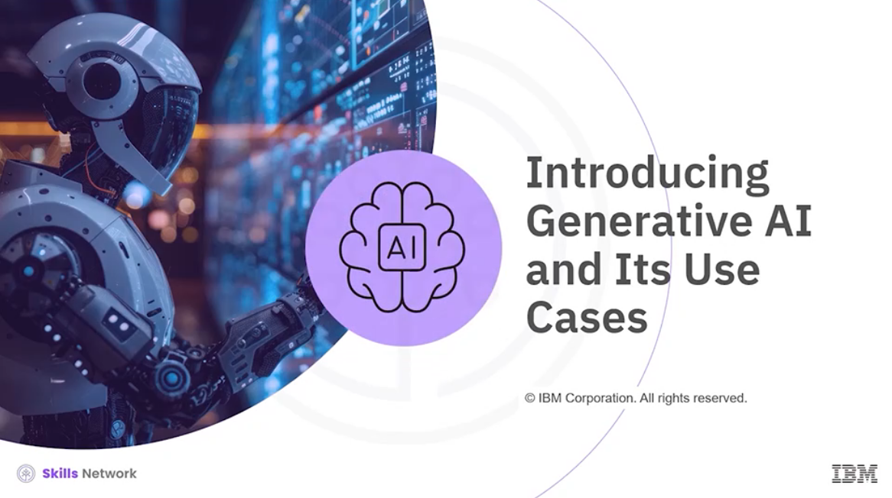

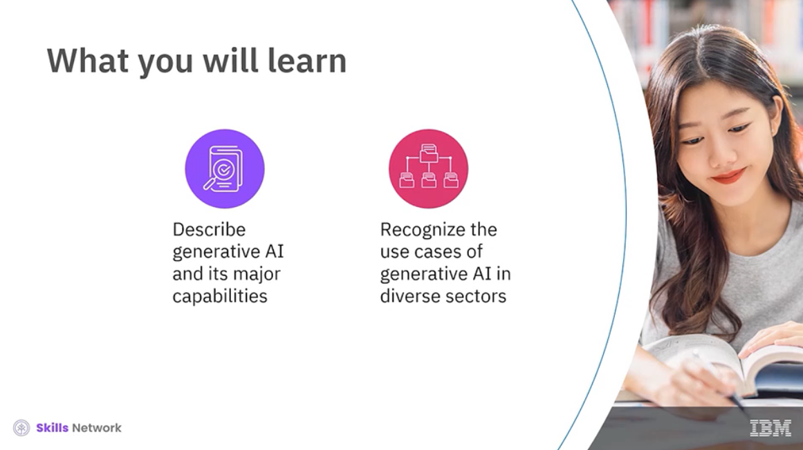

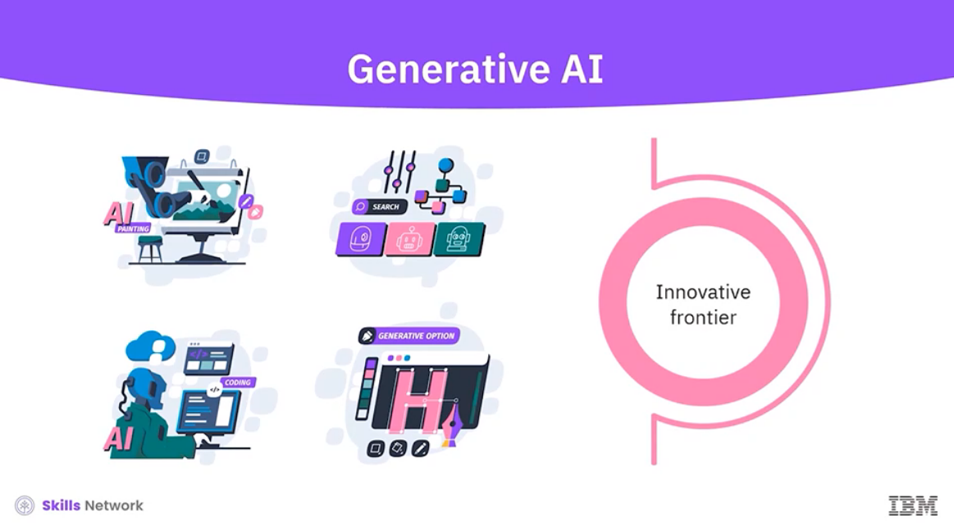

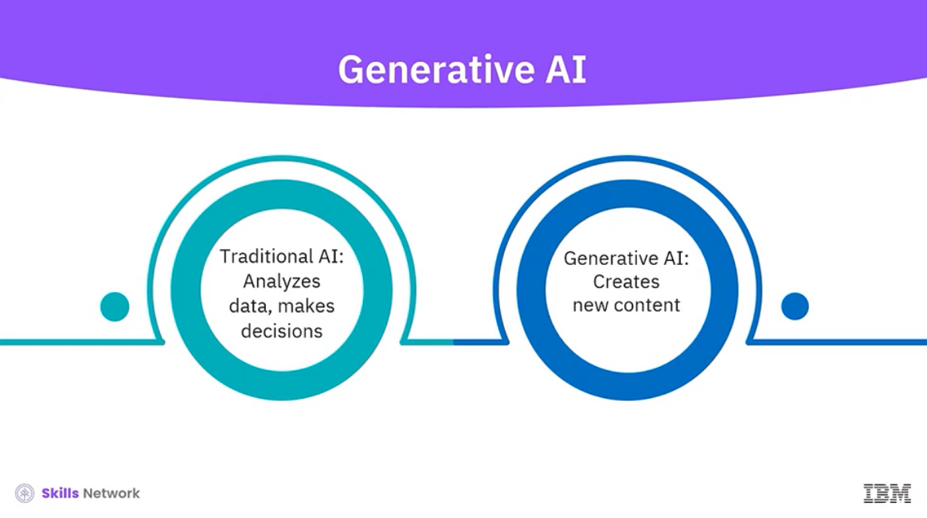

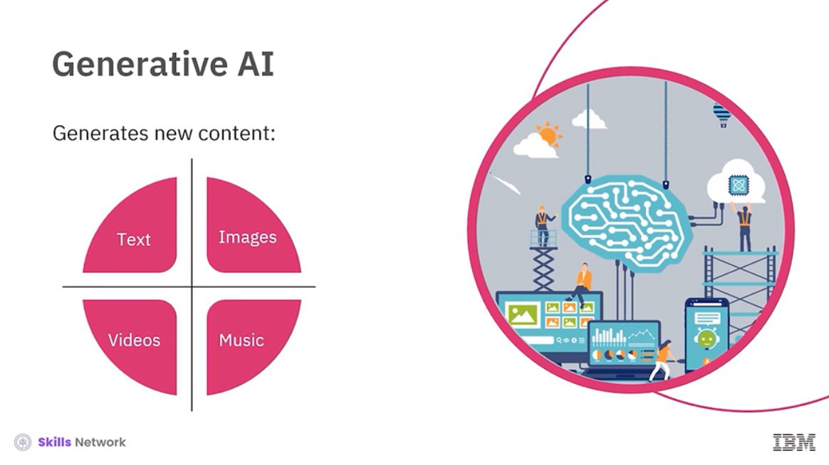

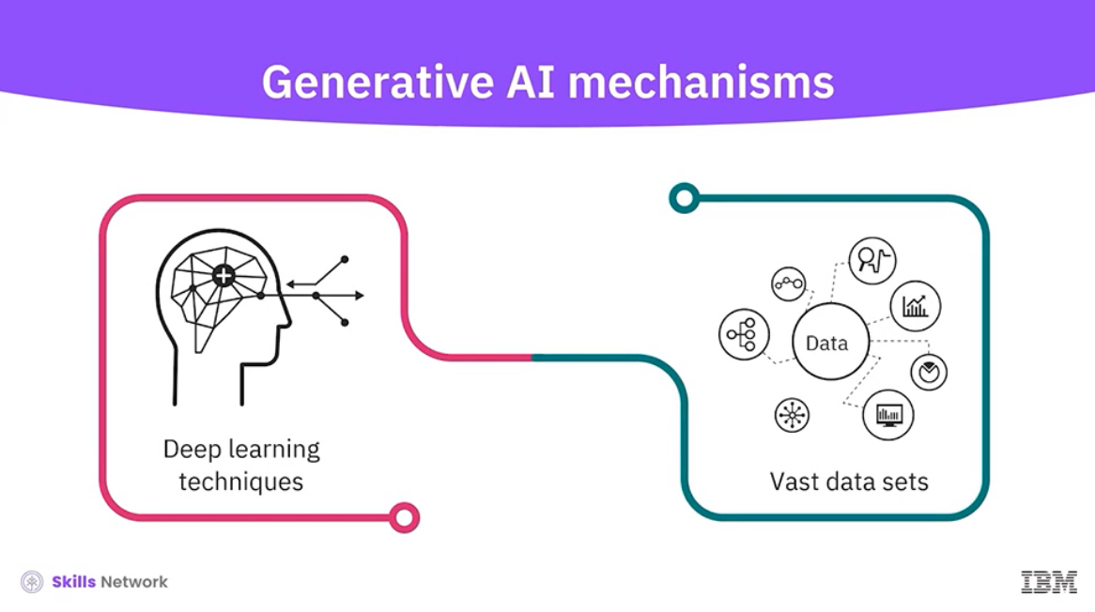

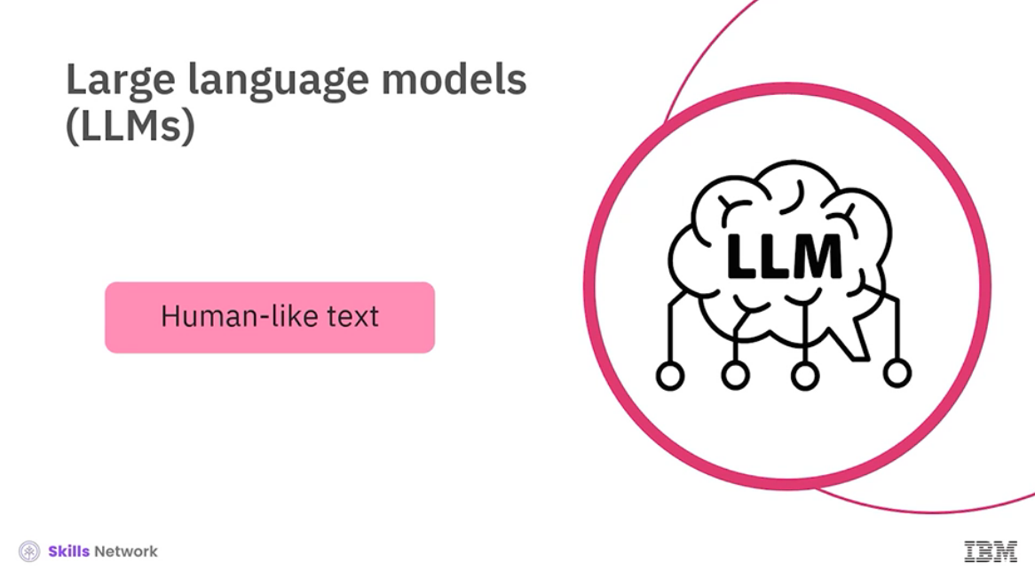

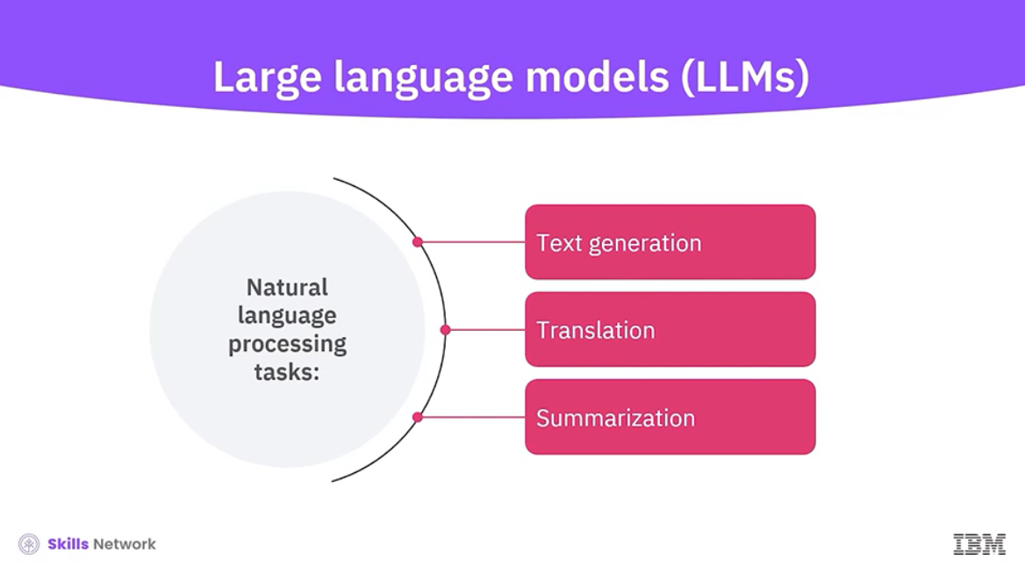

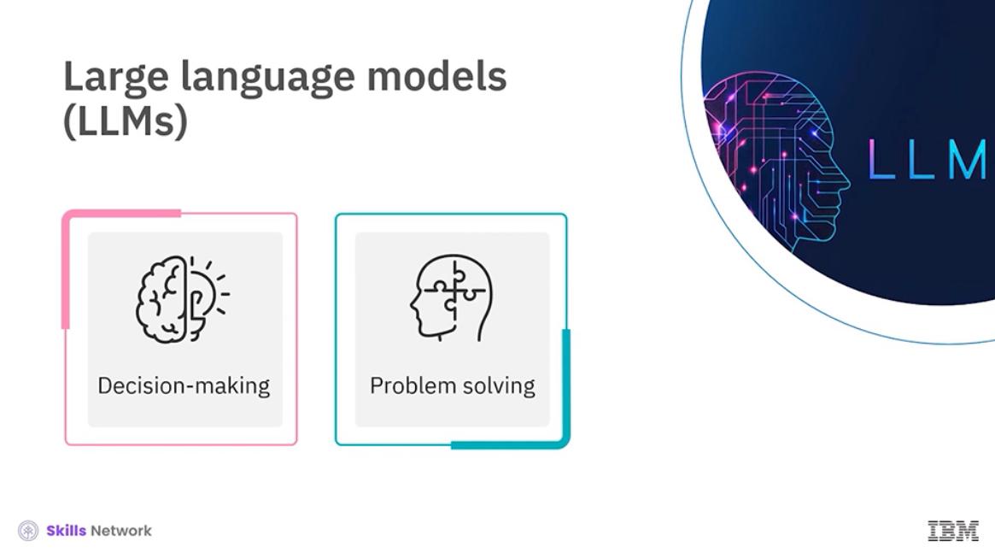

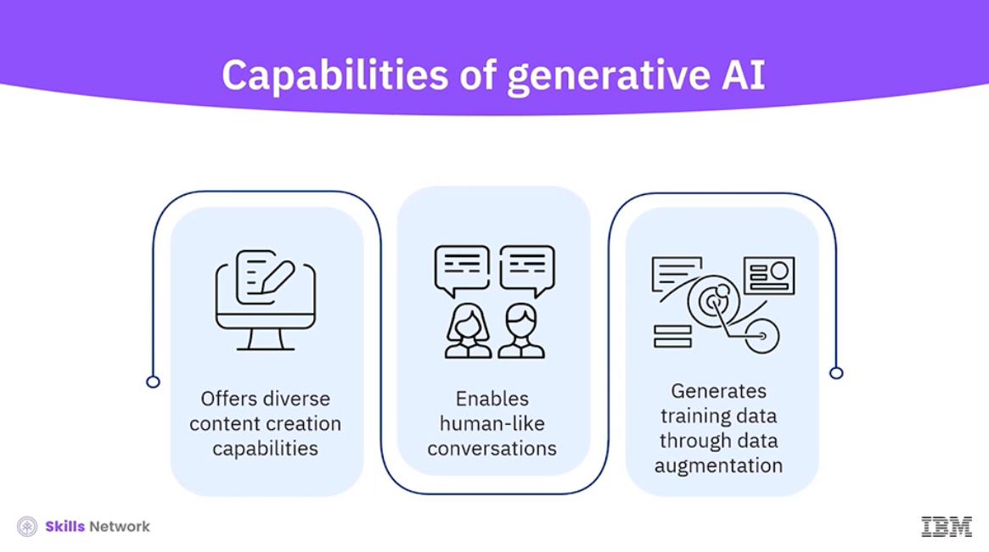

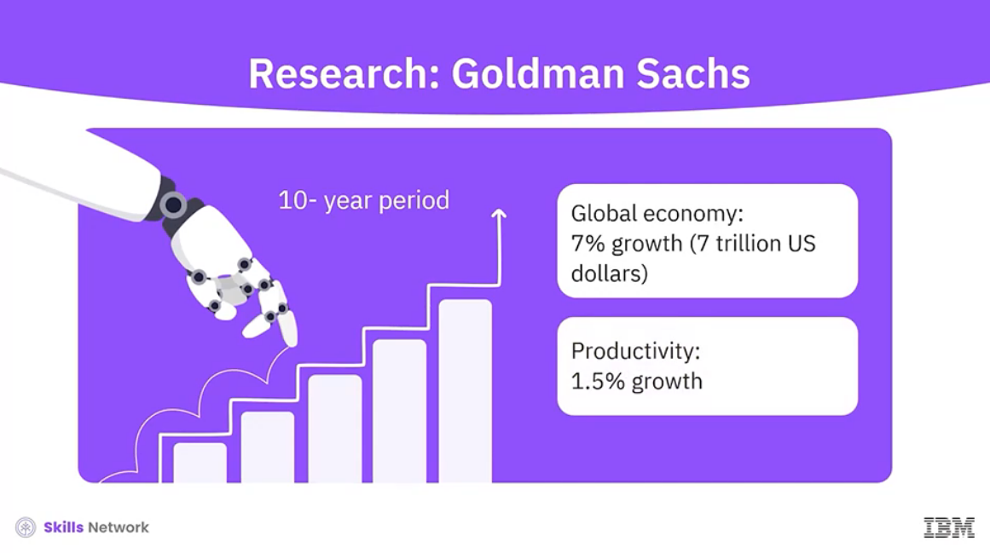

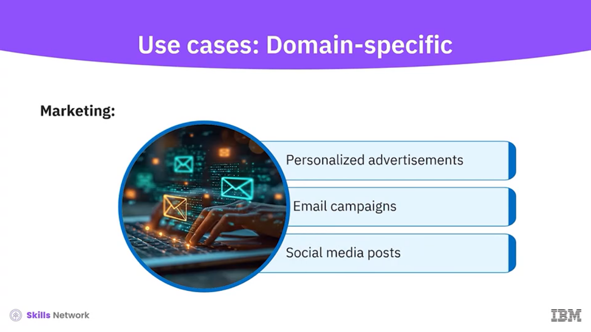

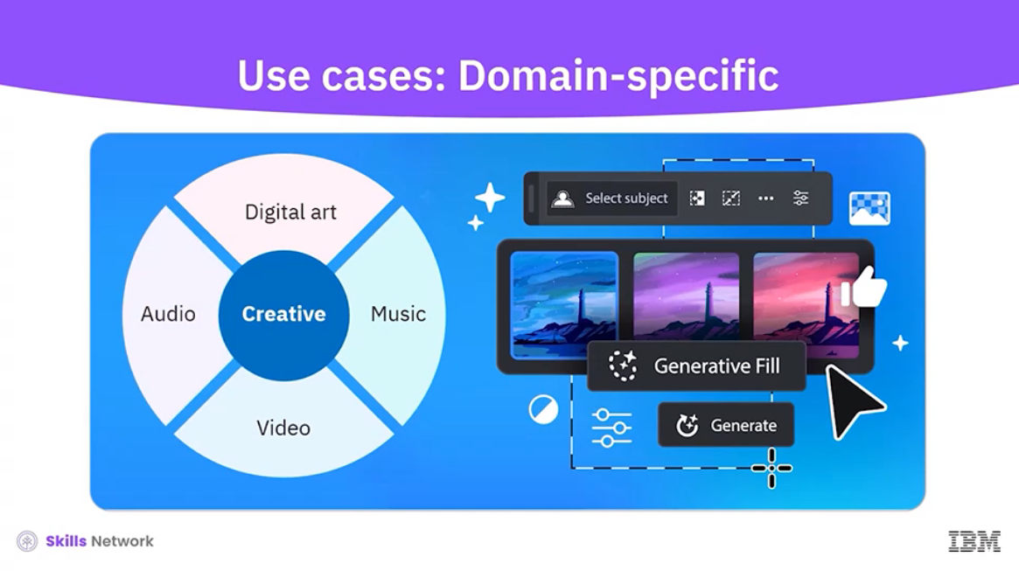

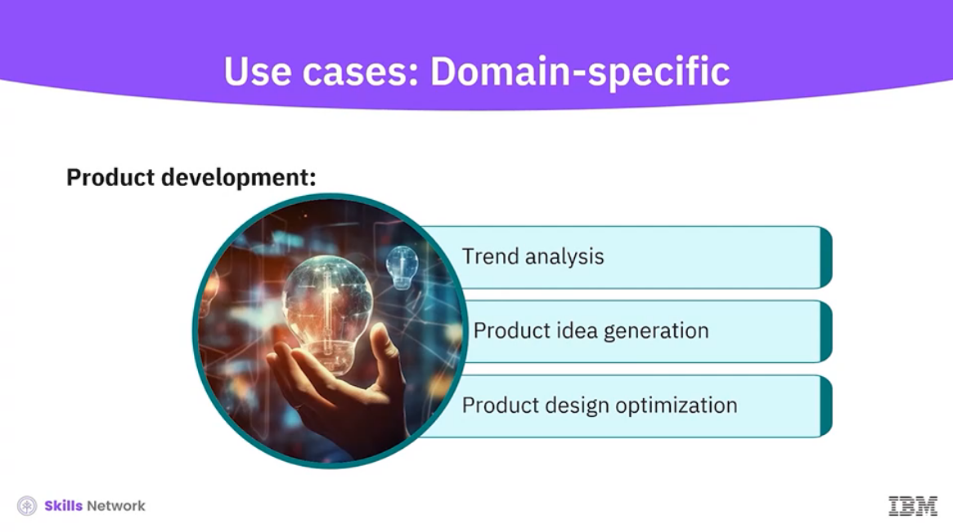

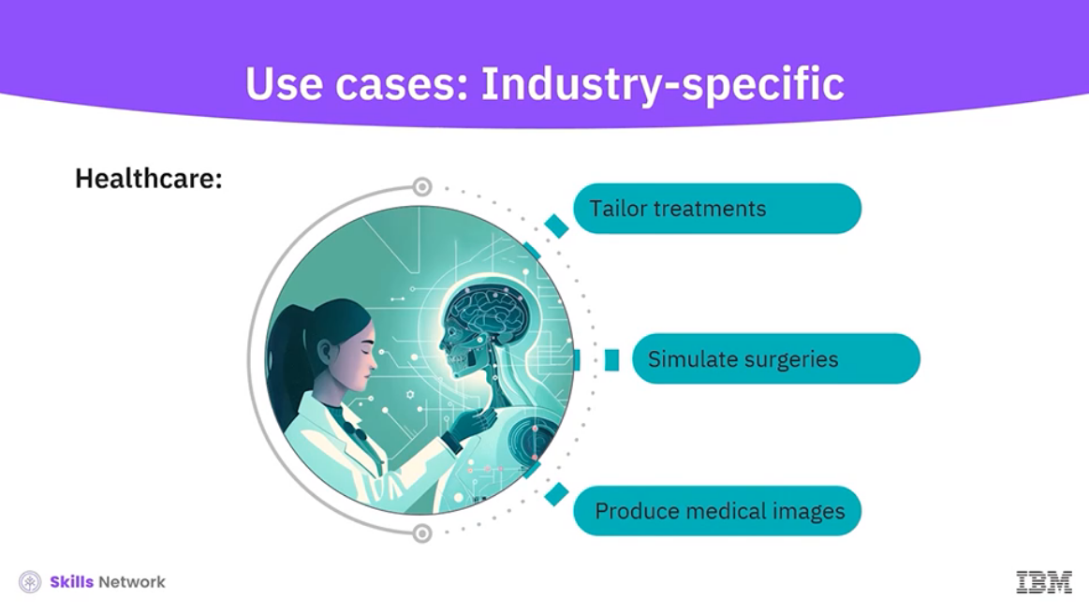

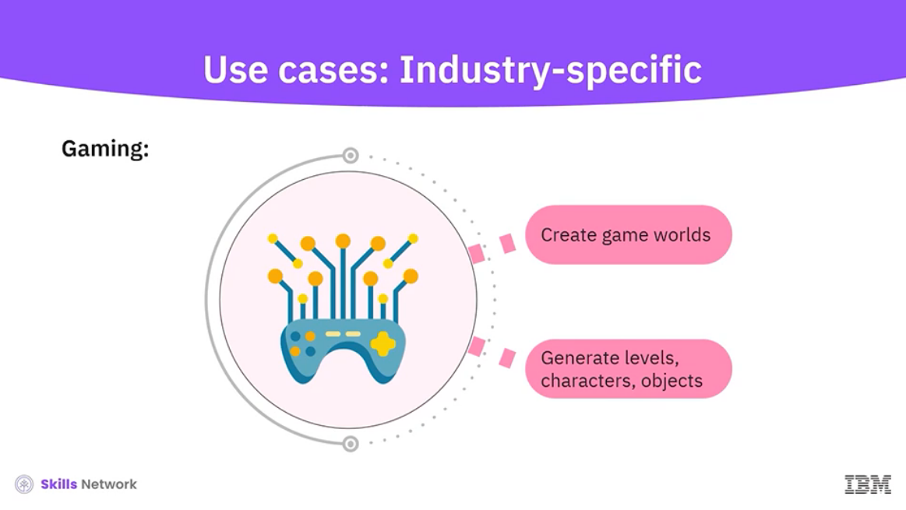

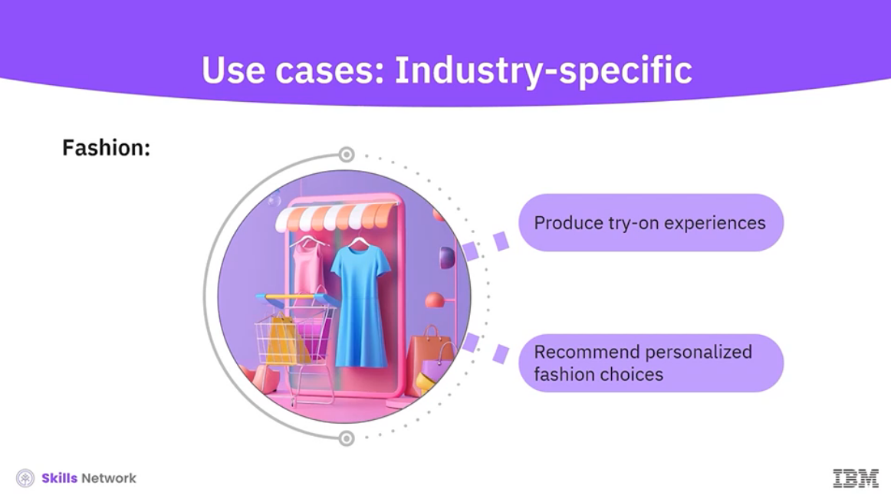

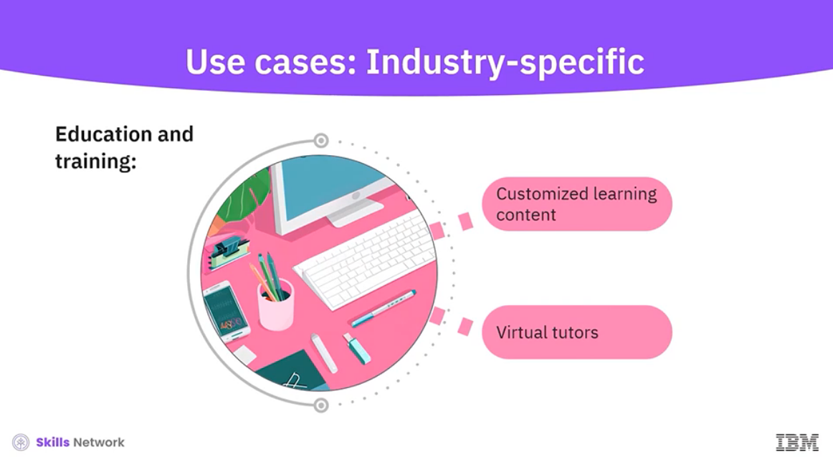

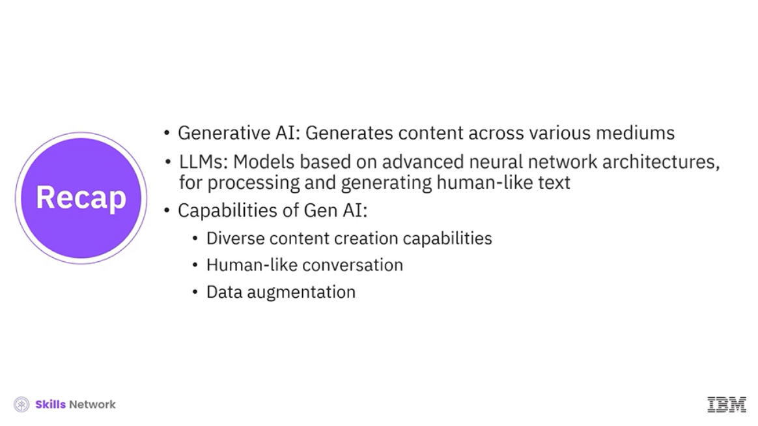

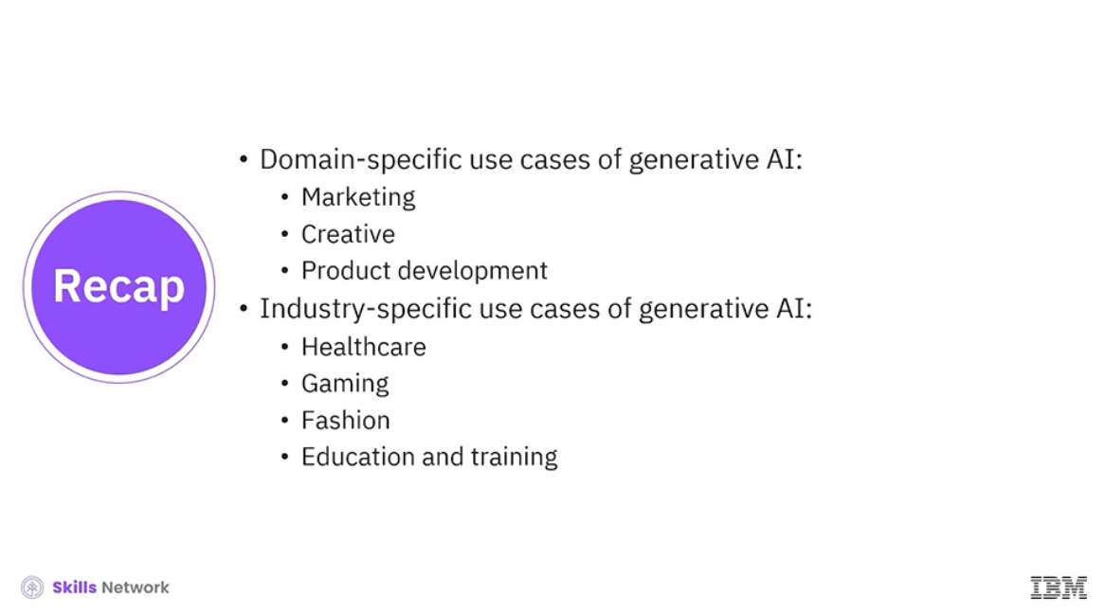

______________________________________________________________________________

**The Evolution of AI: Traditional AI vs. Generative AI**

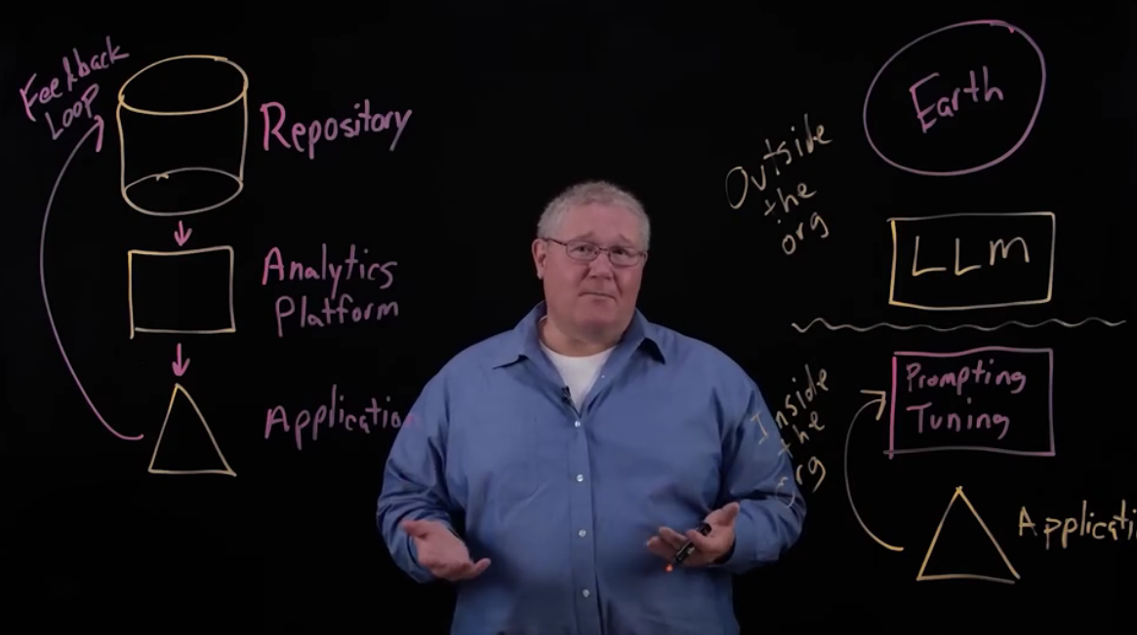

______________________________________________________________________________

**Artificial Intelligence – Are We There Yet?**

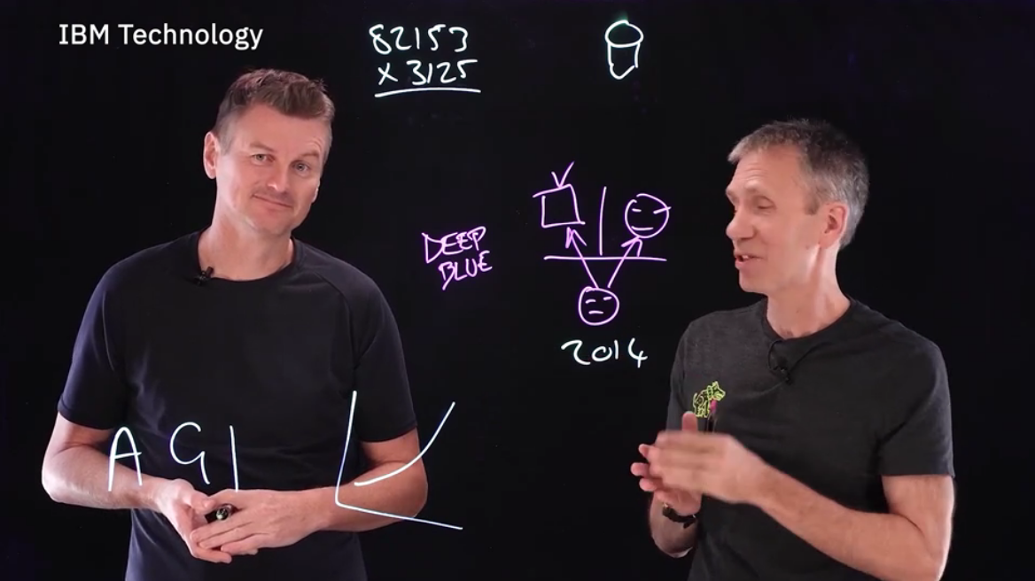

______________________________________________________________________________

**AI in Daily Life**

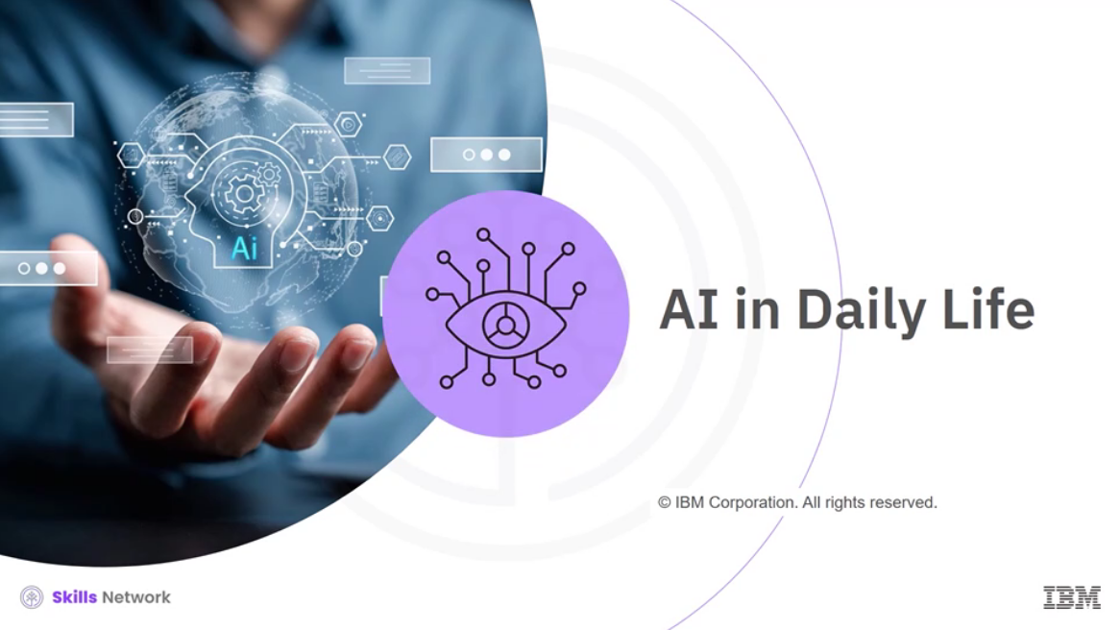

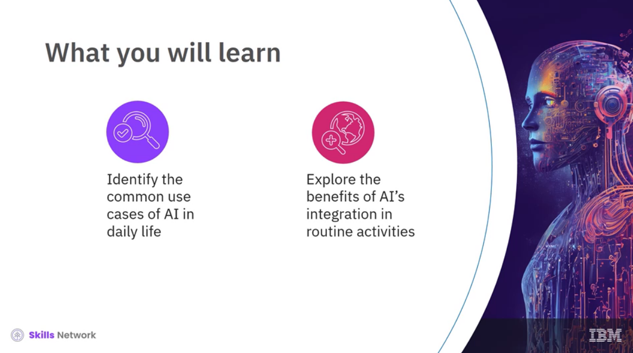

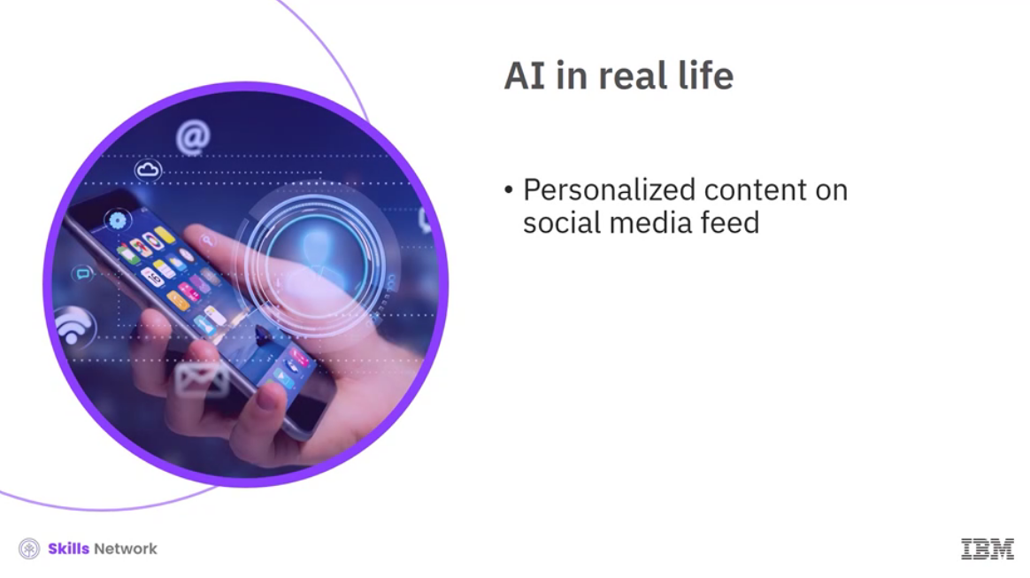

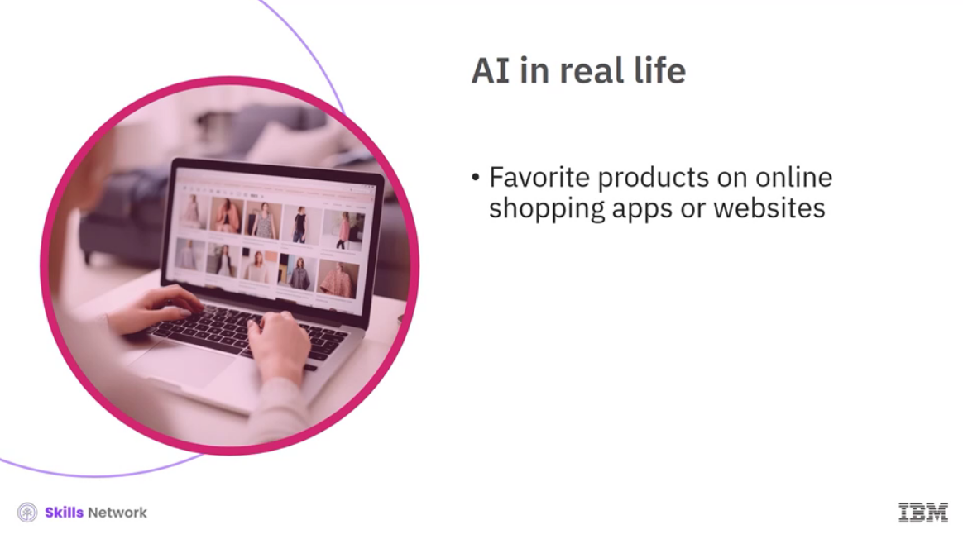

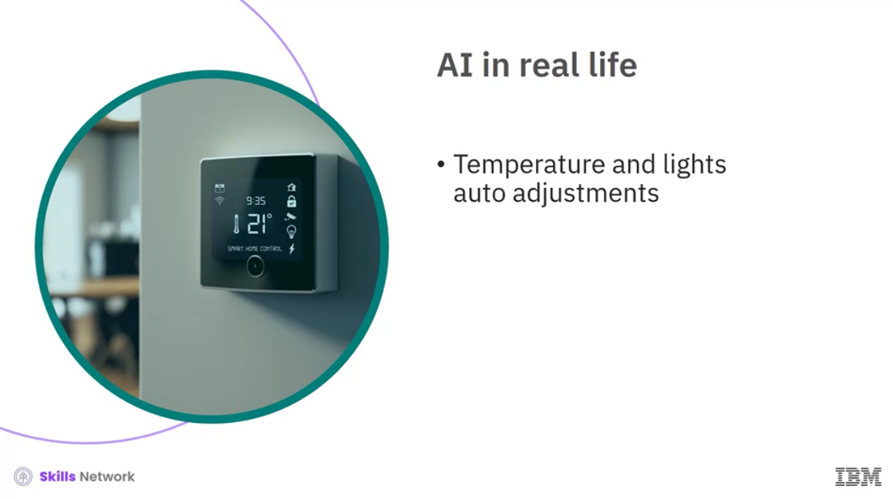

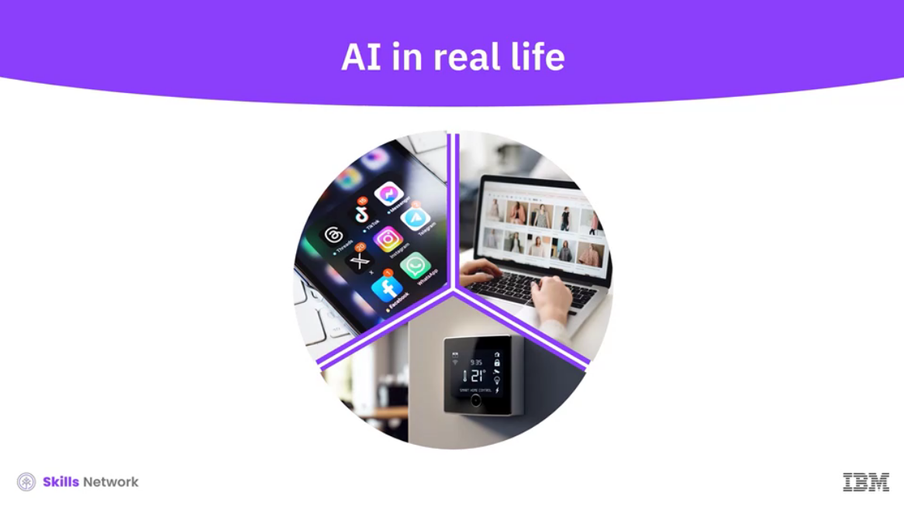

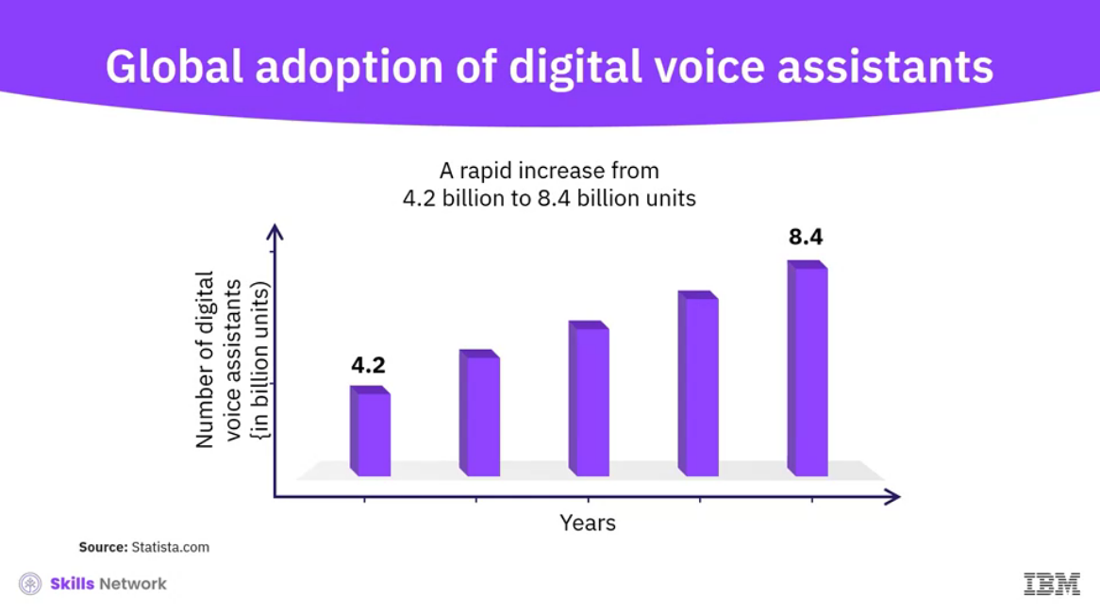

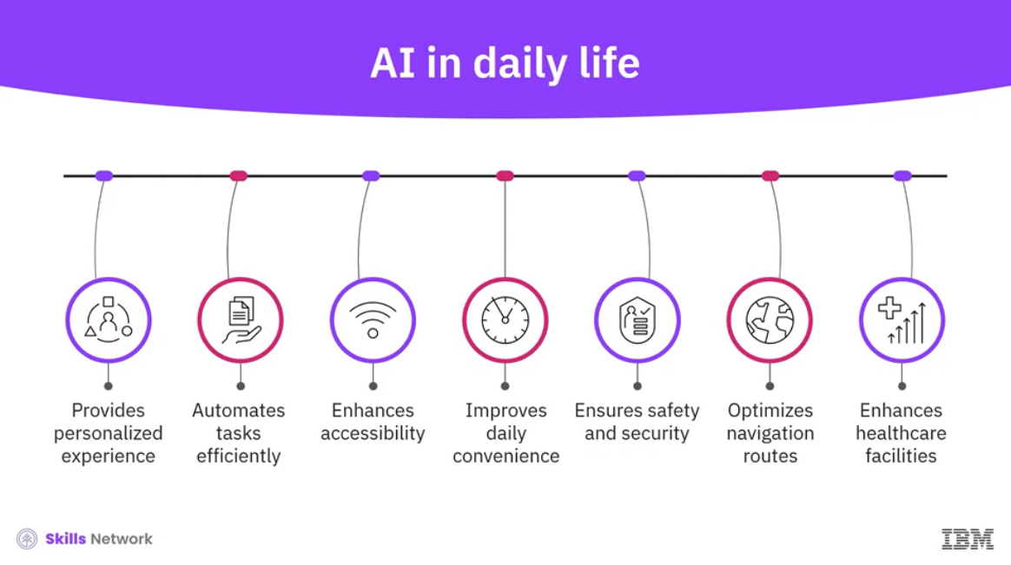

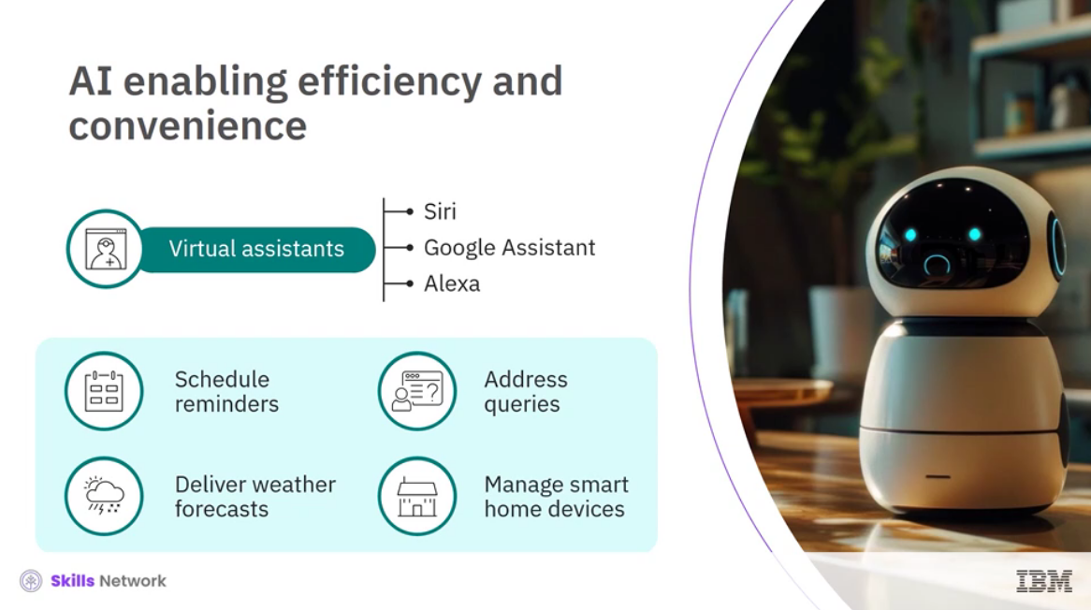

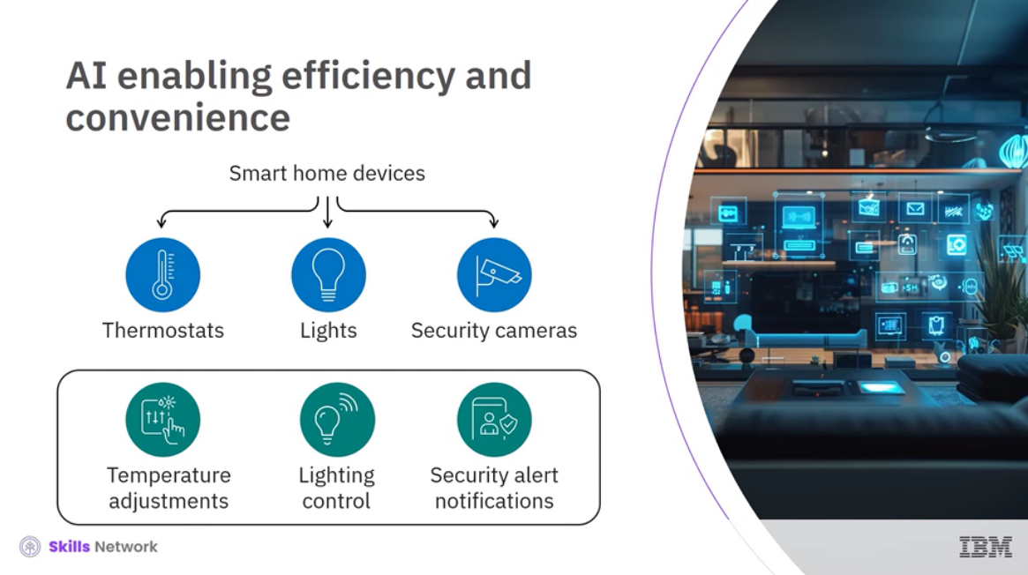

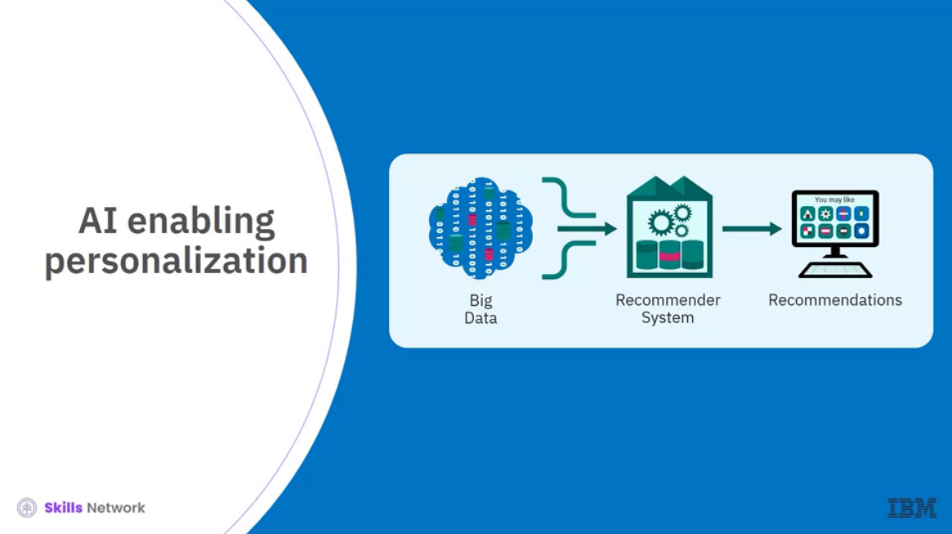

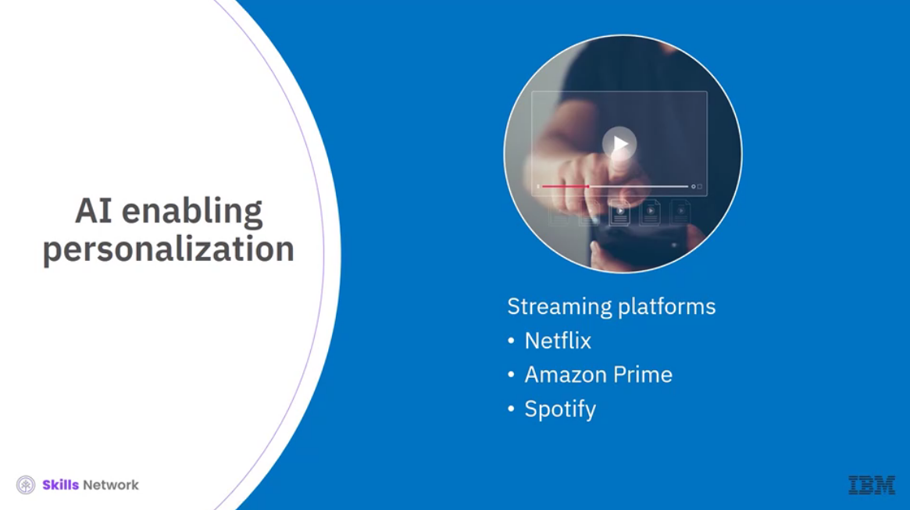

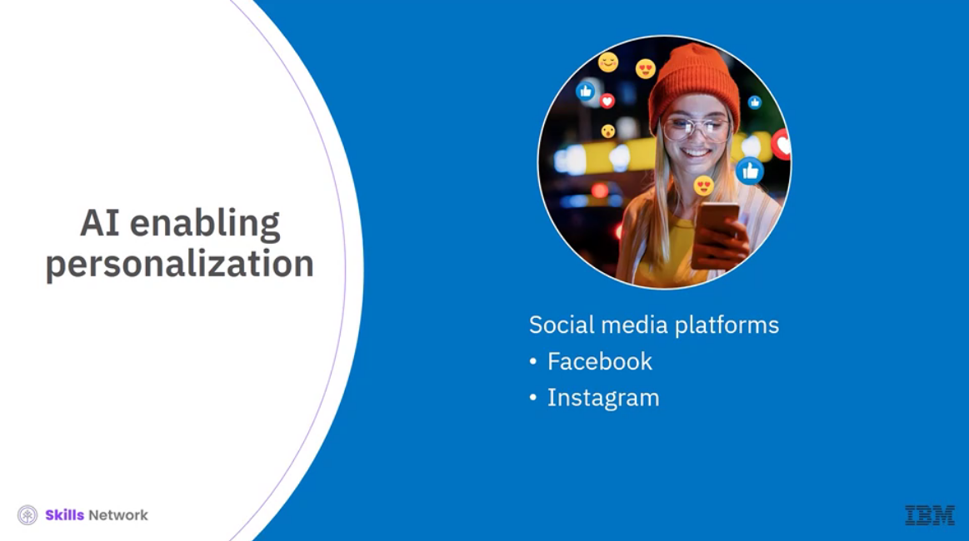

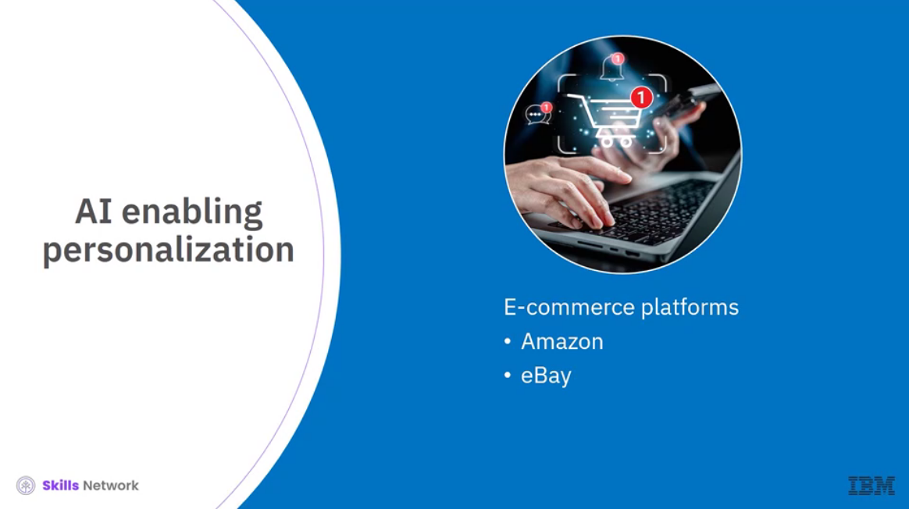

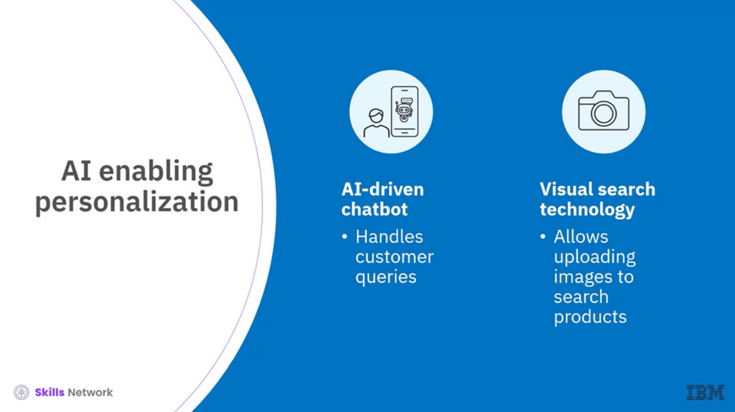

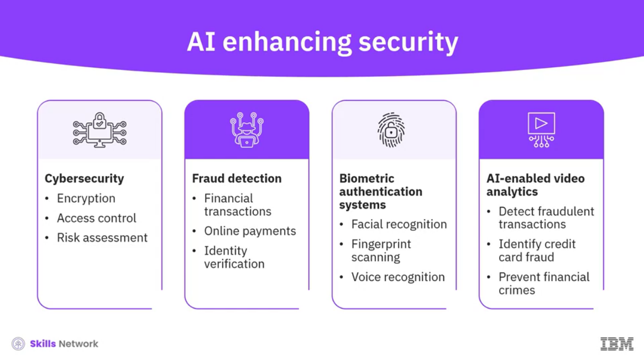

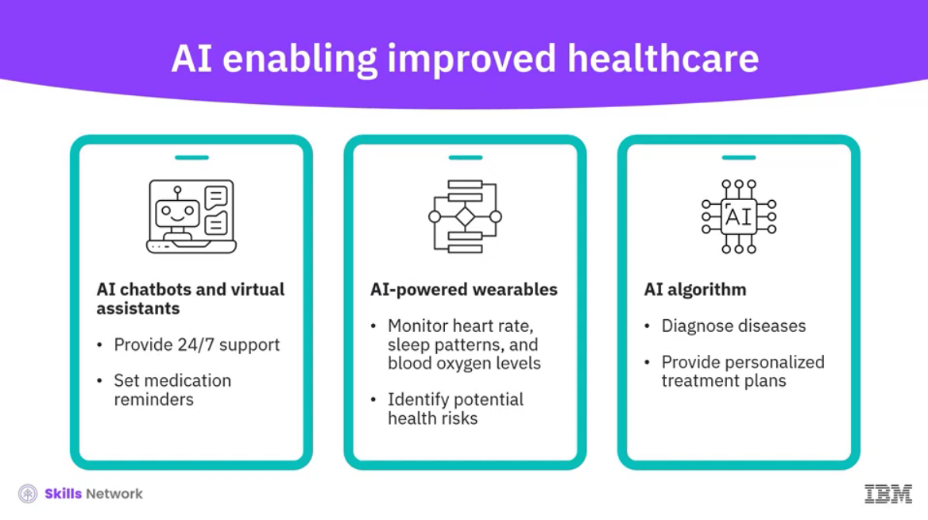

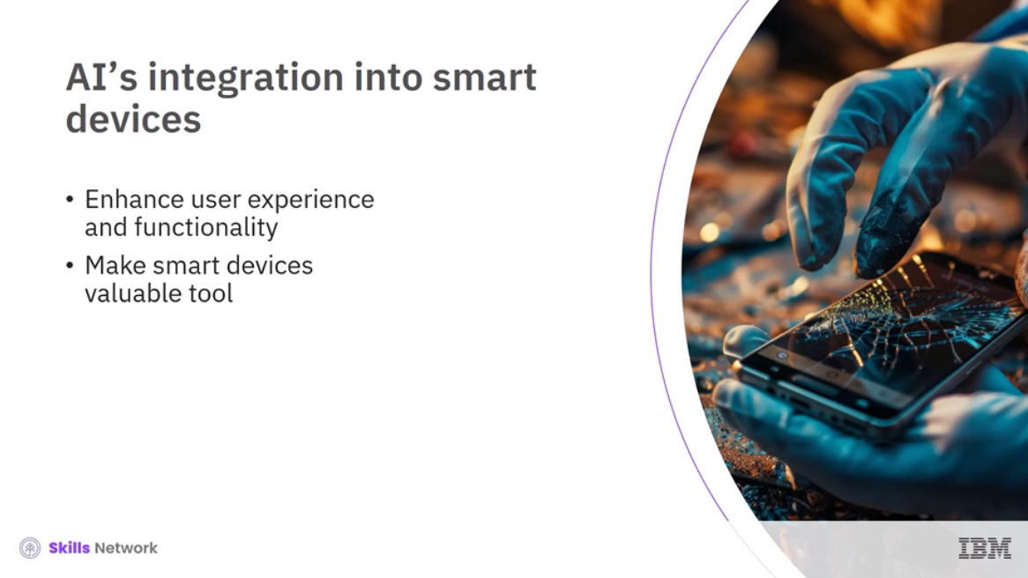

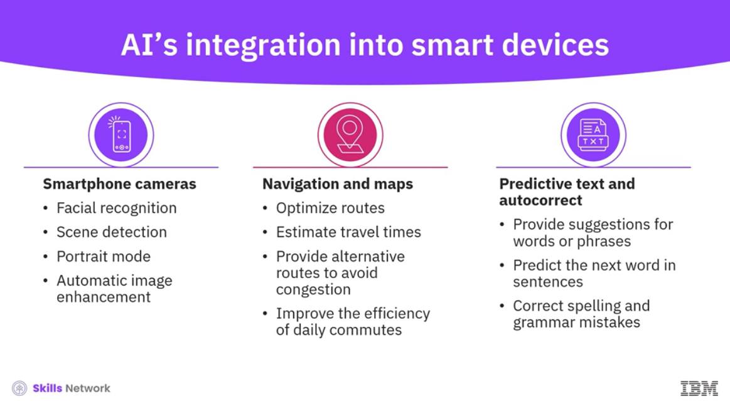

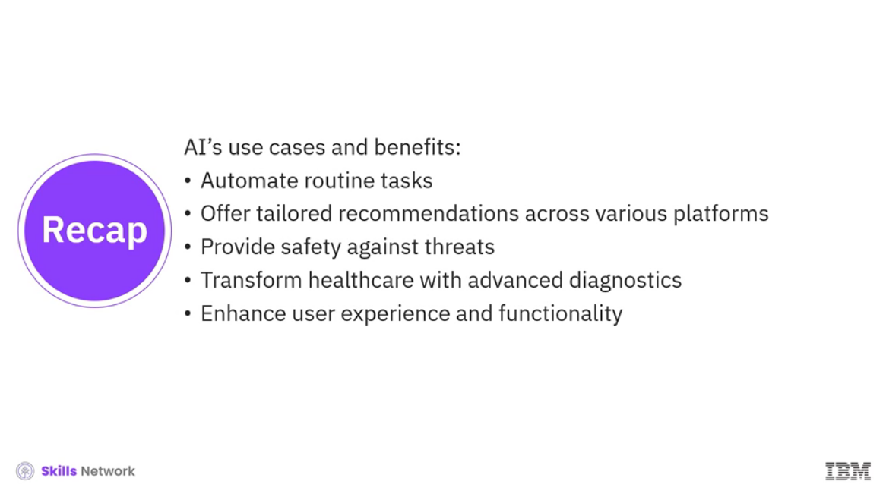

______________________________________________________________________________

**AI Chatbots and Smart Assistants**

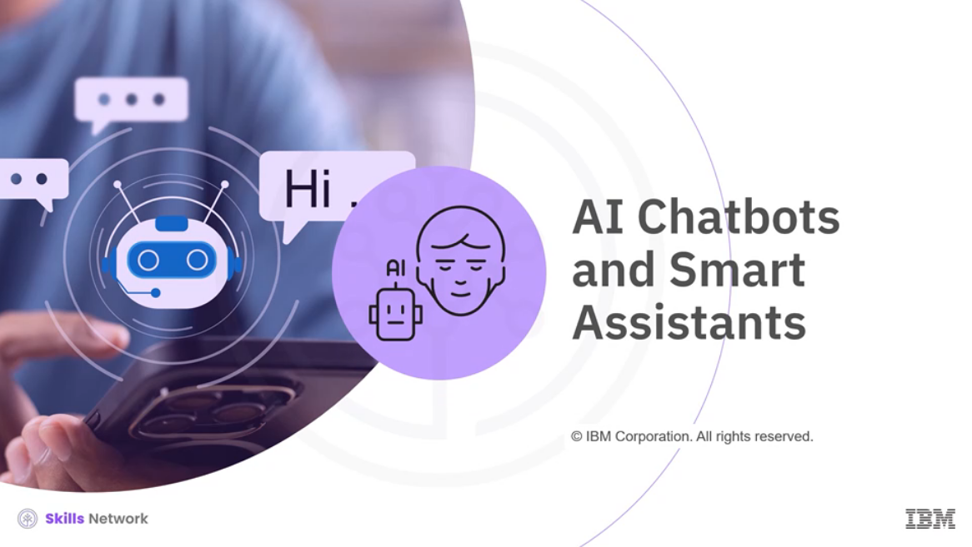

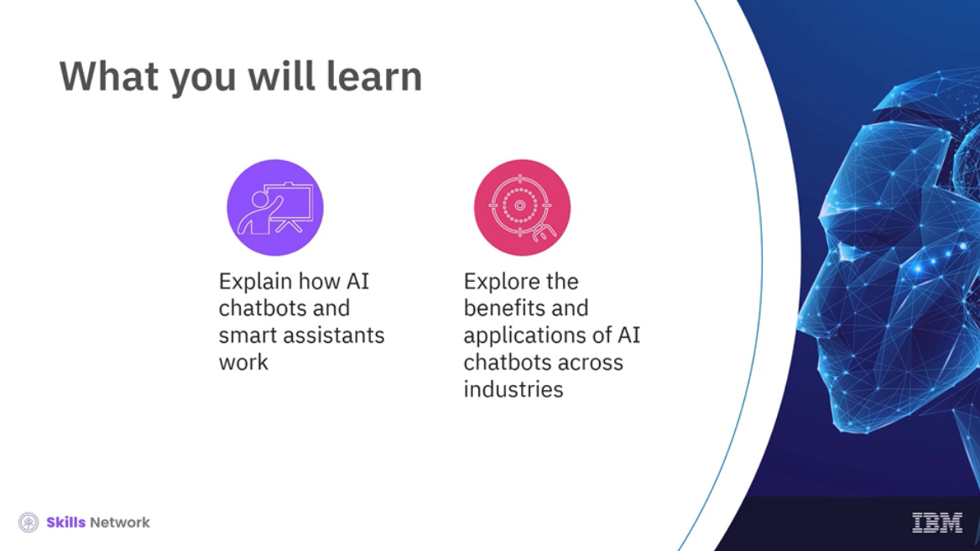

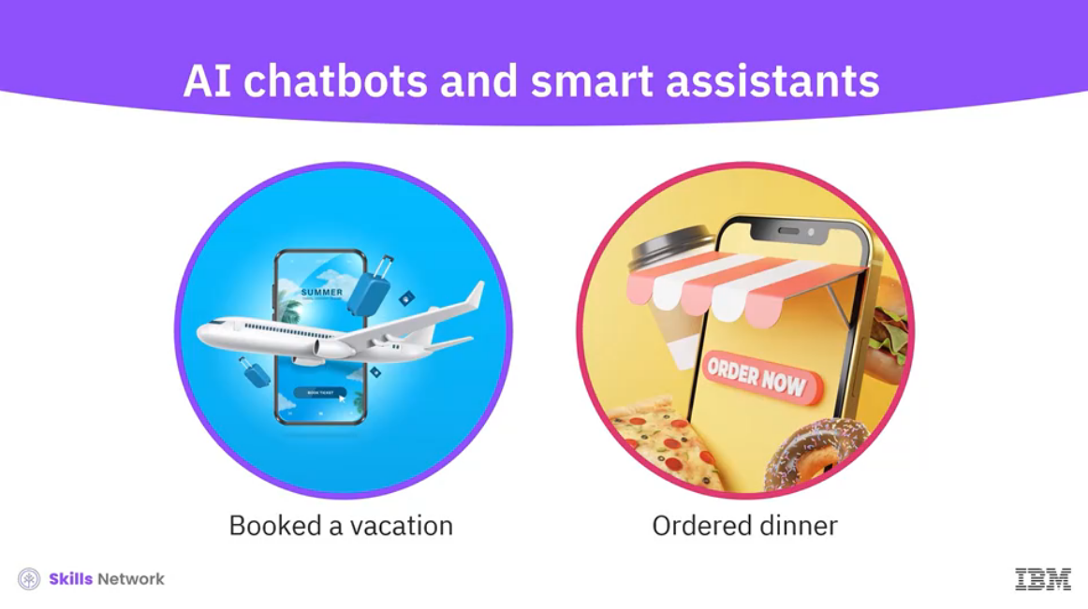

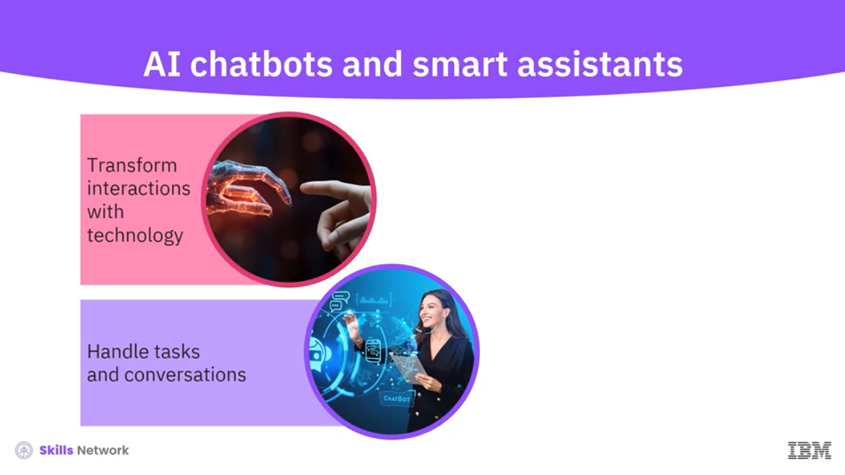

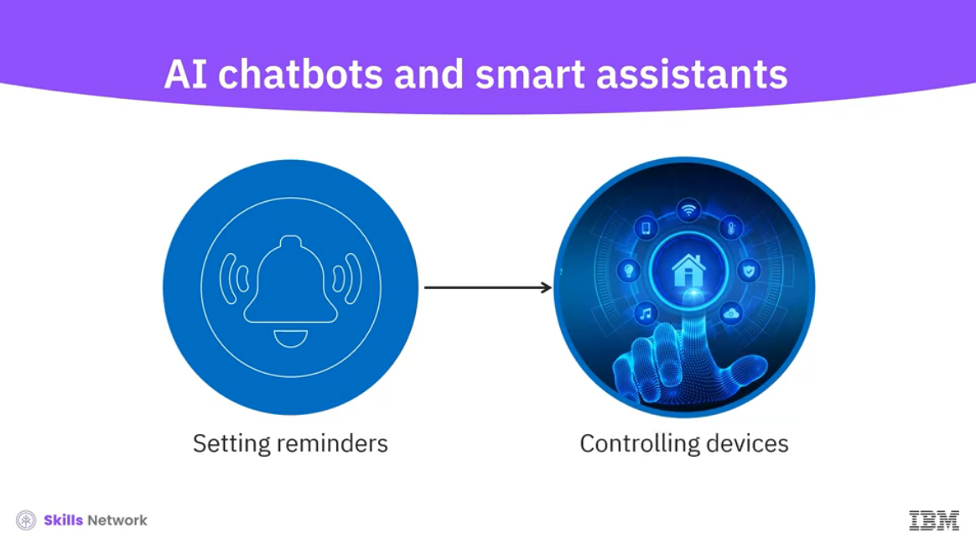

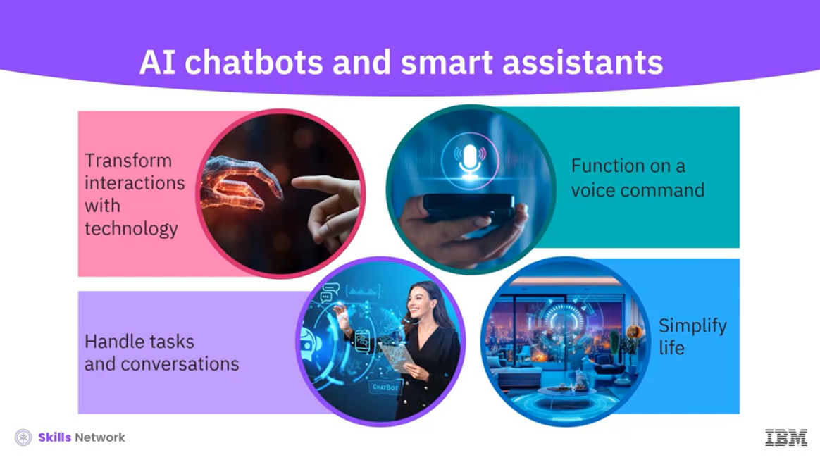

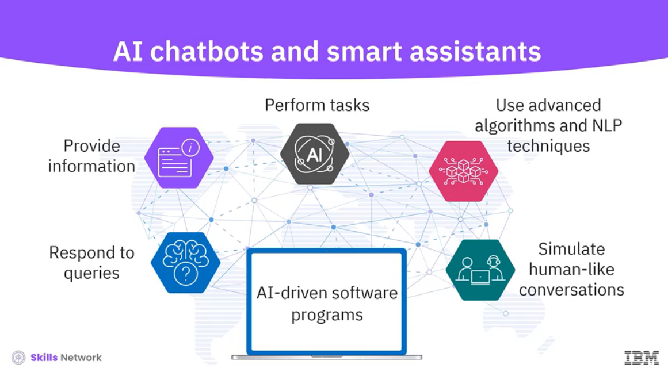

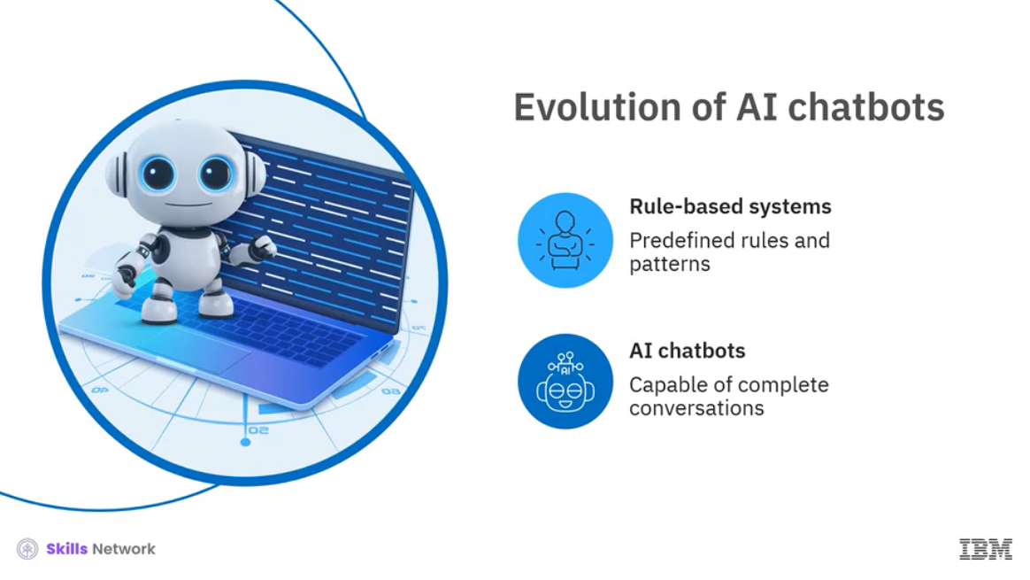

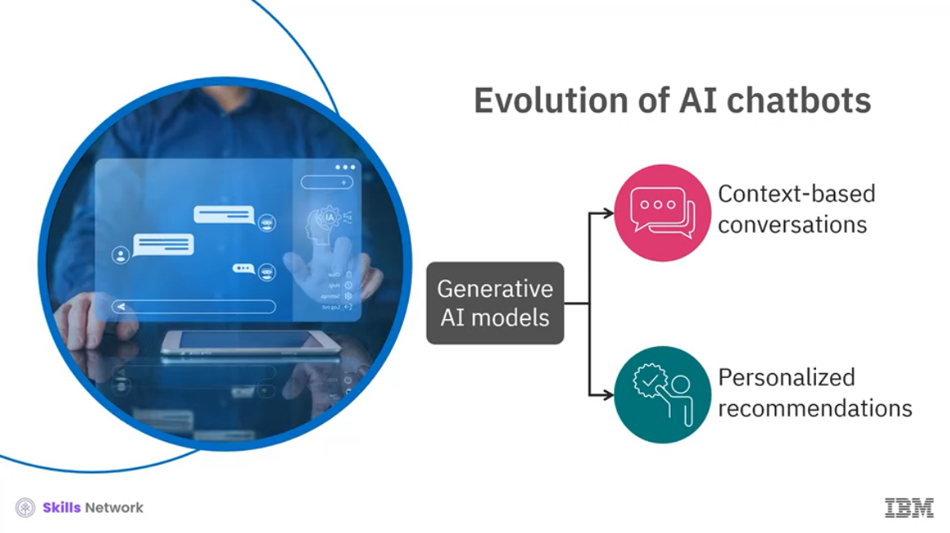

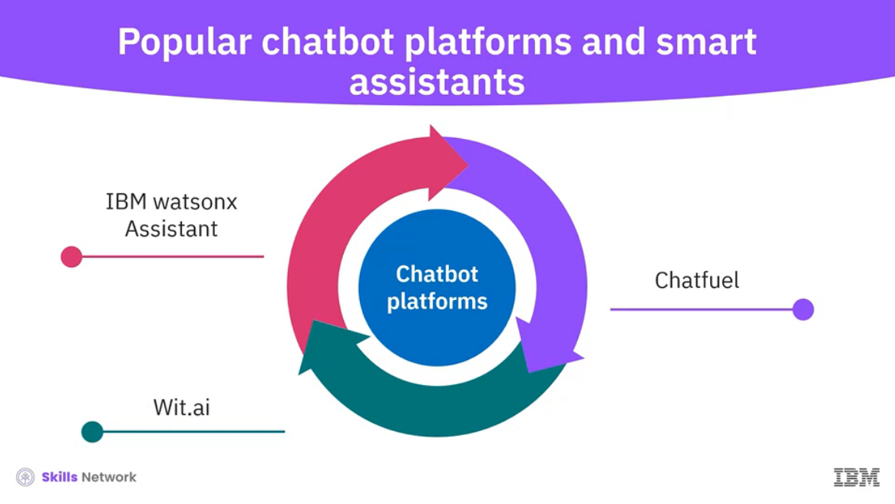

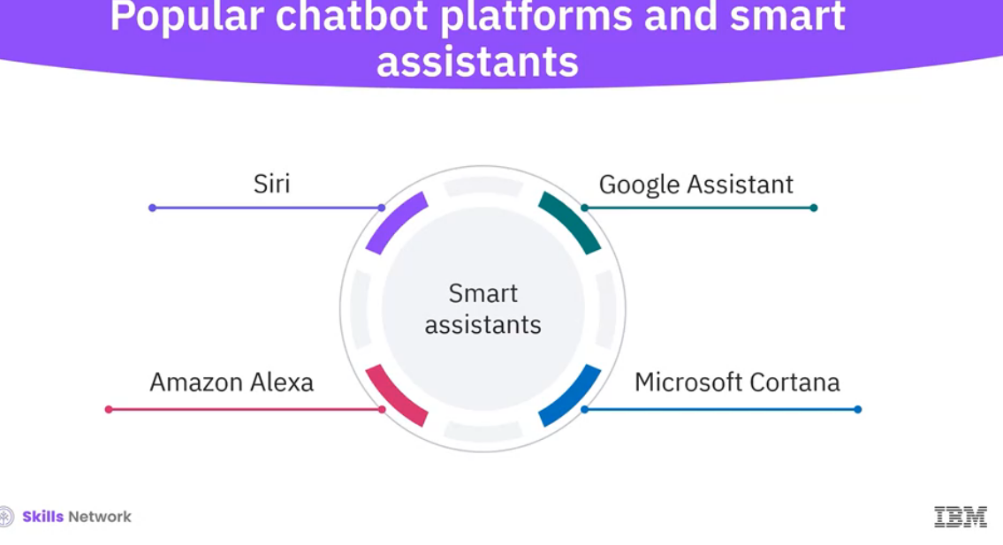

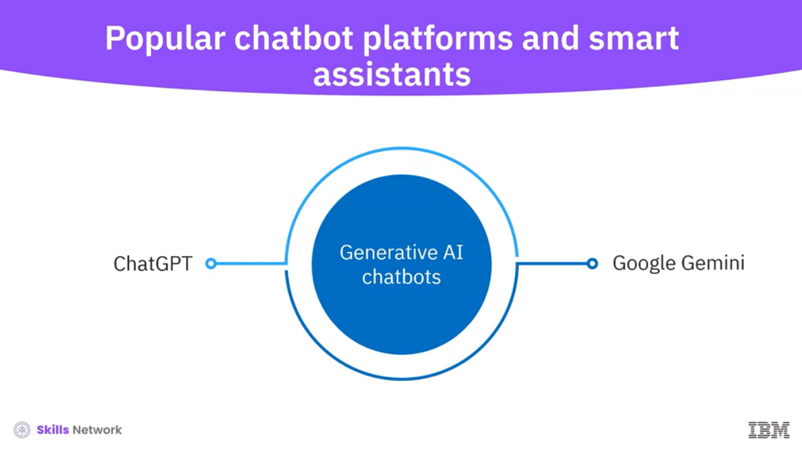

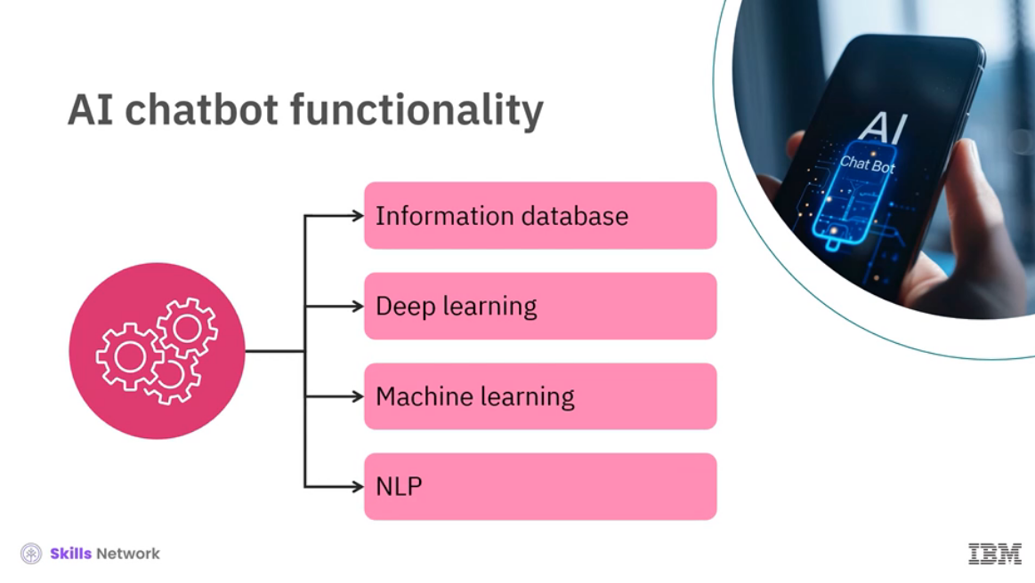

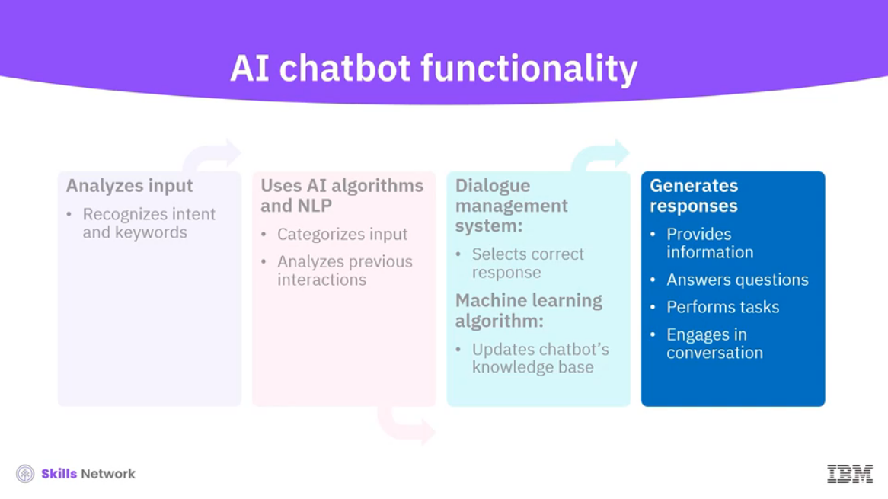

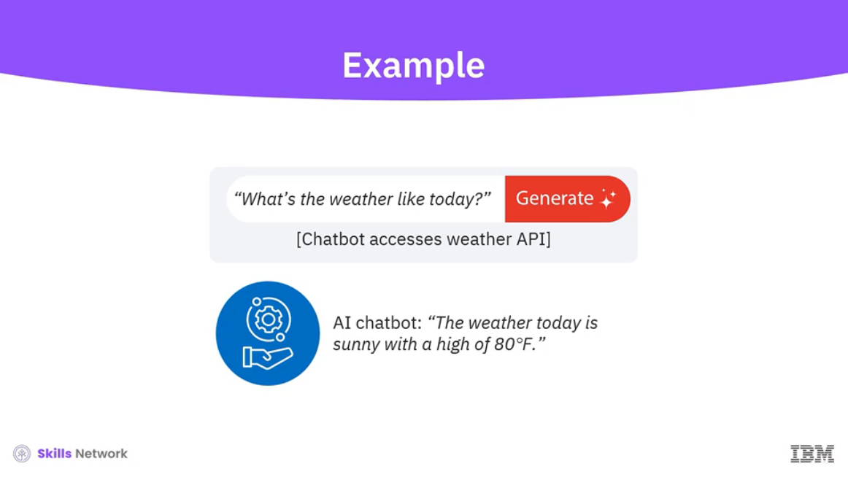

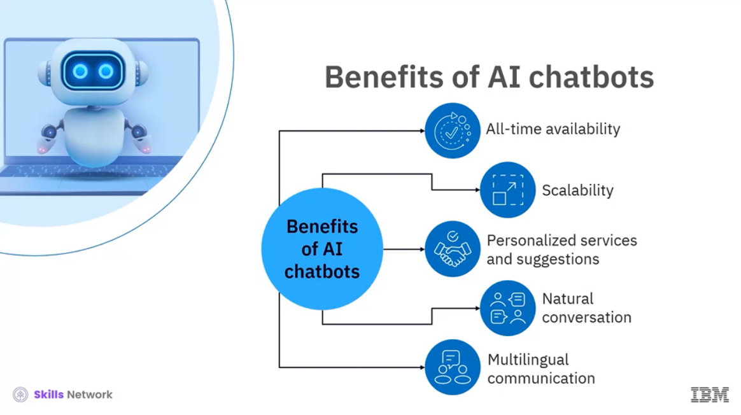

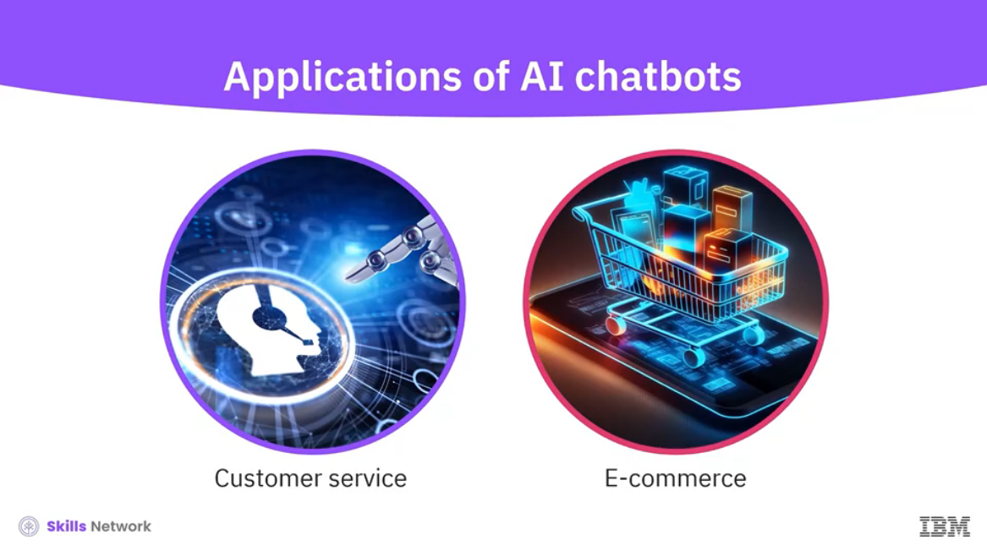

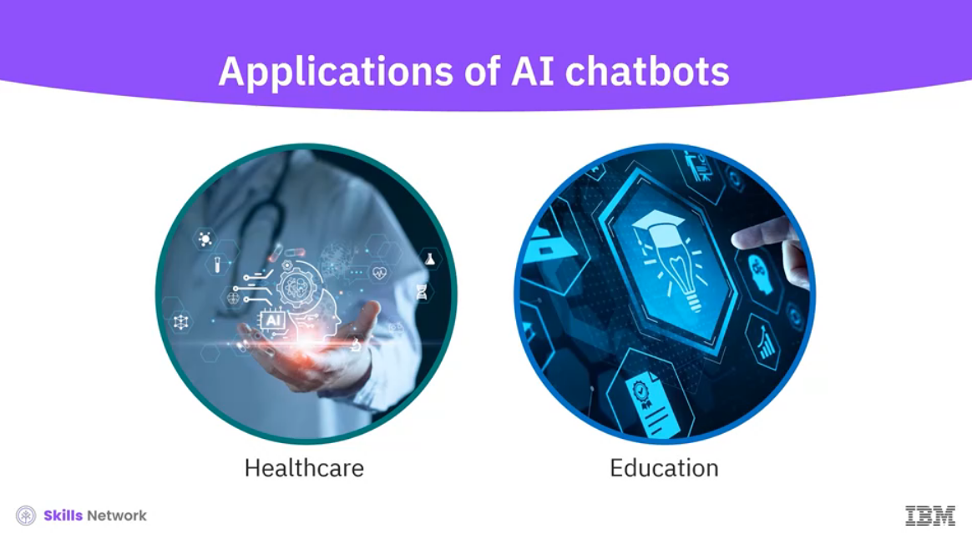

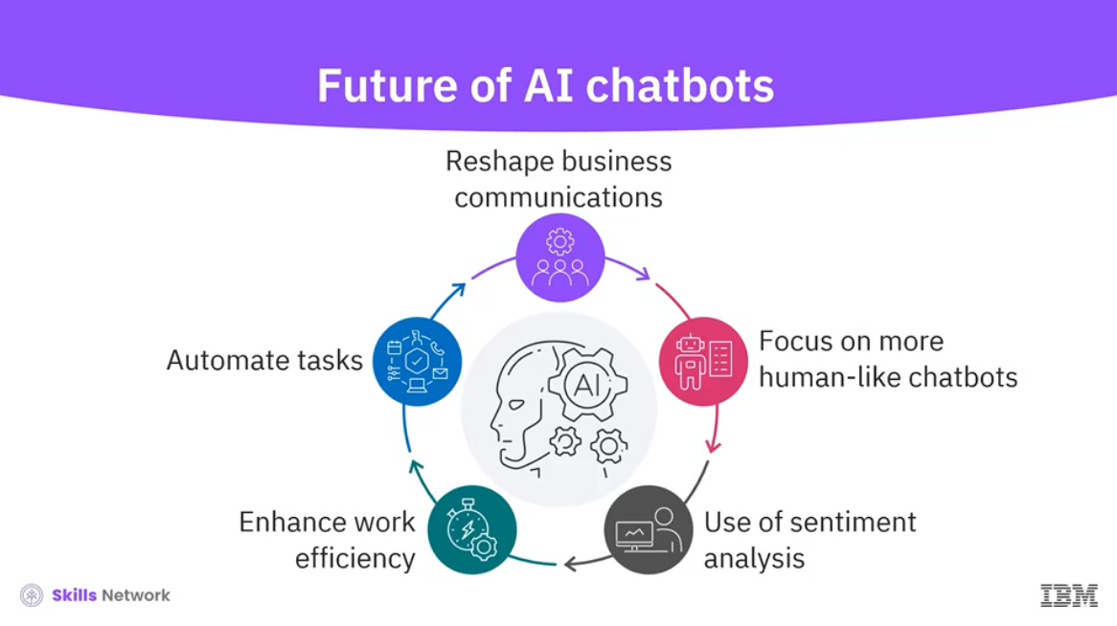

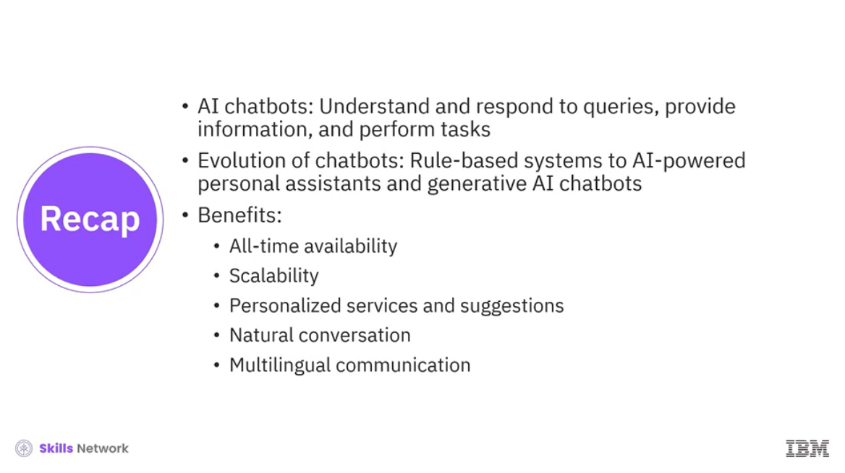

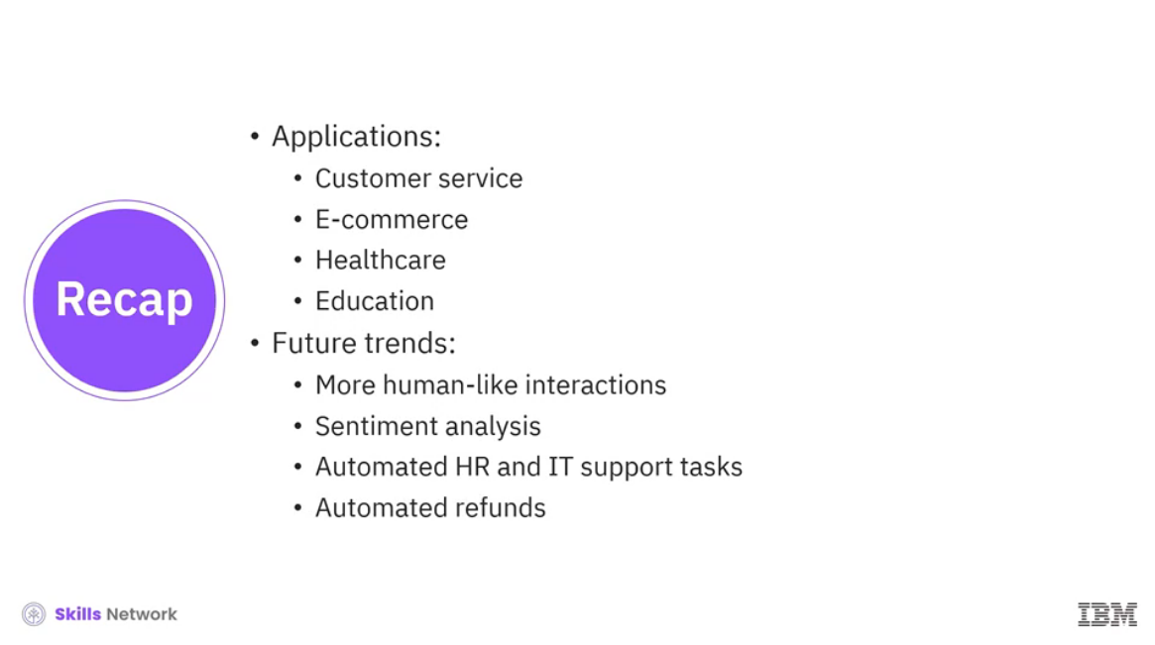

______________________________________________________________________________

**What is a Chatbot?**

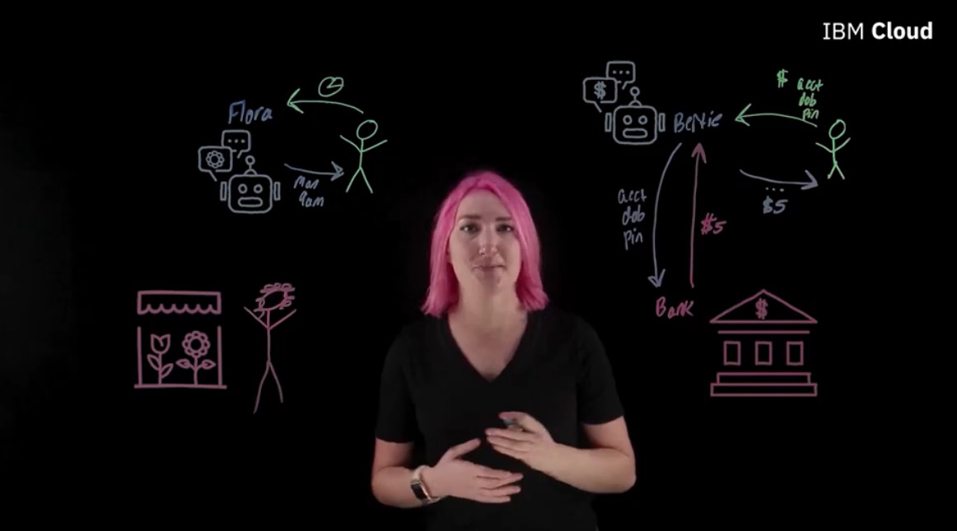

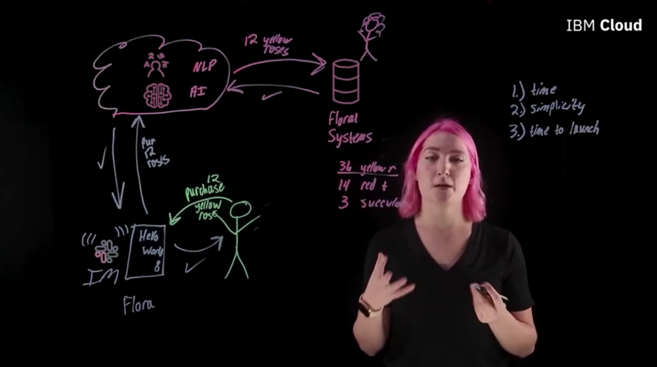

______________________________________________________________________________

**Applications of AI in Different Industries**

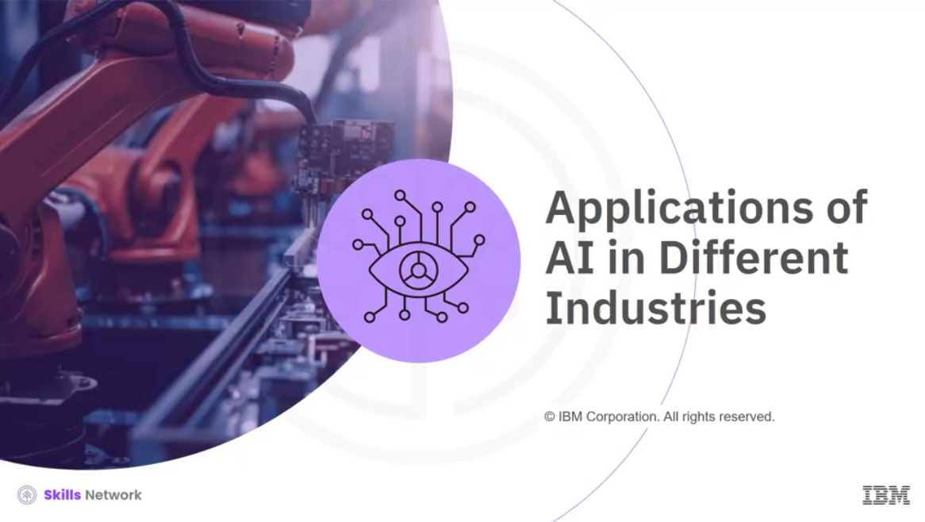

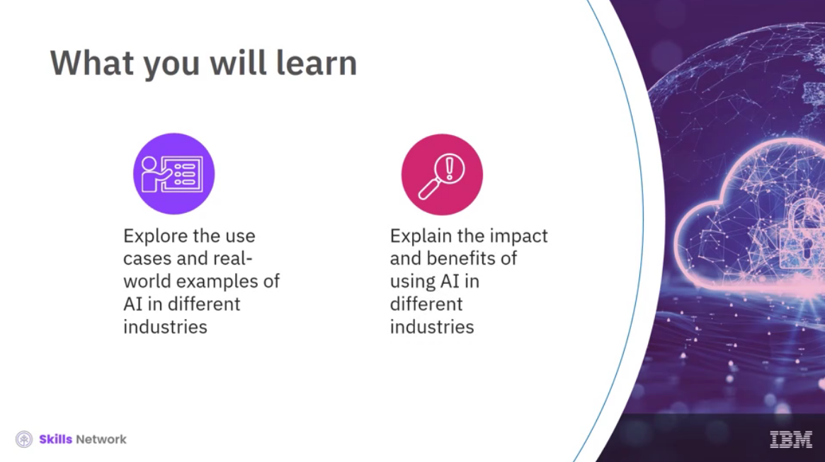

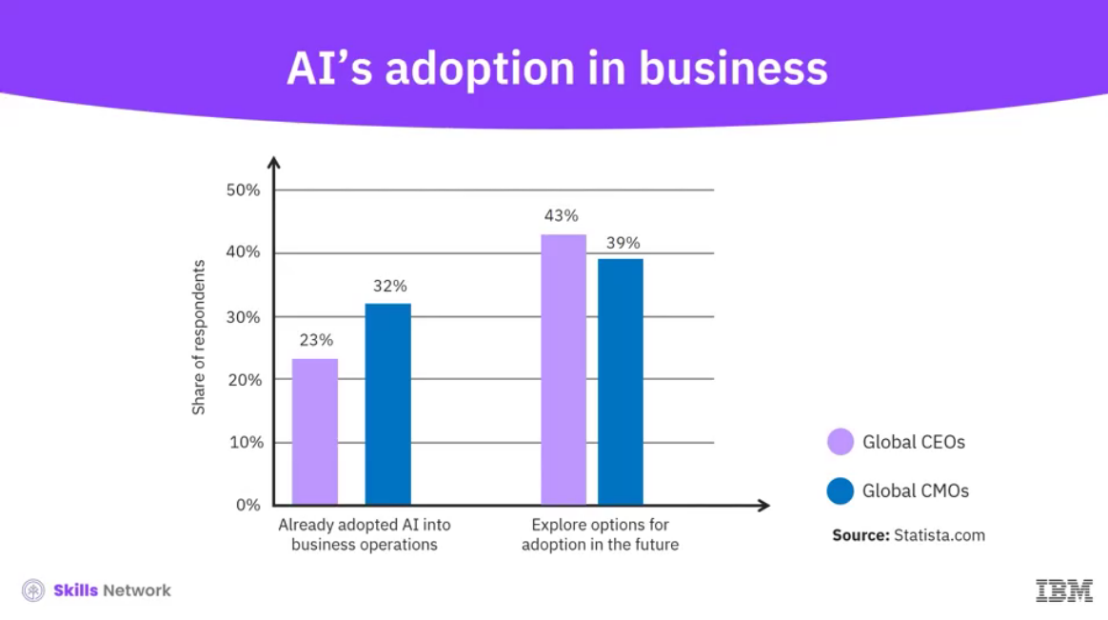

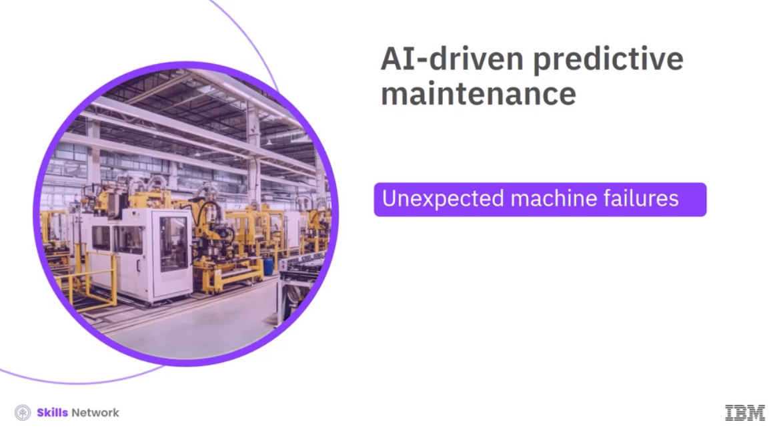

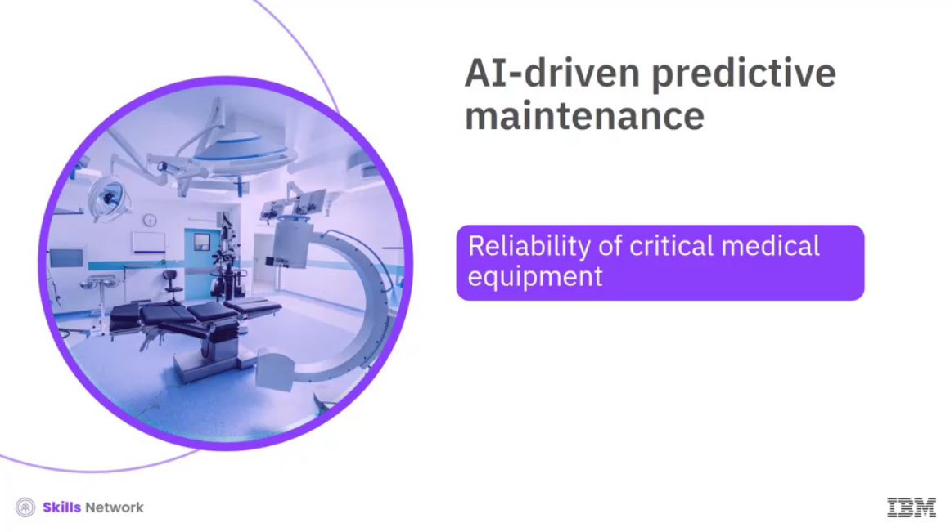

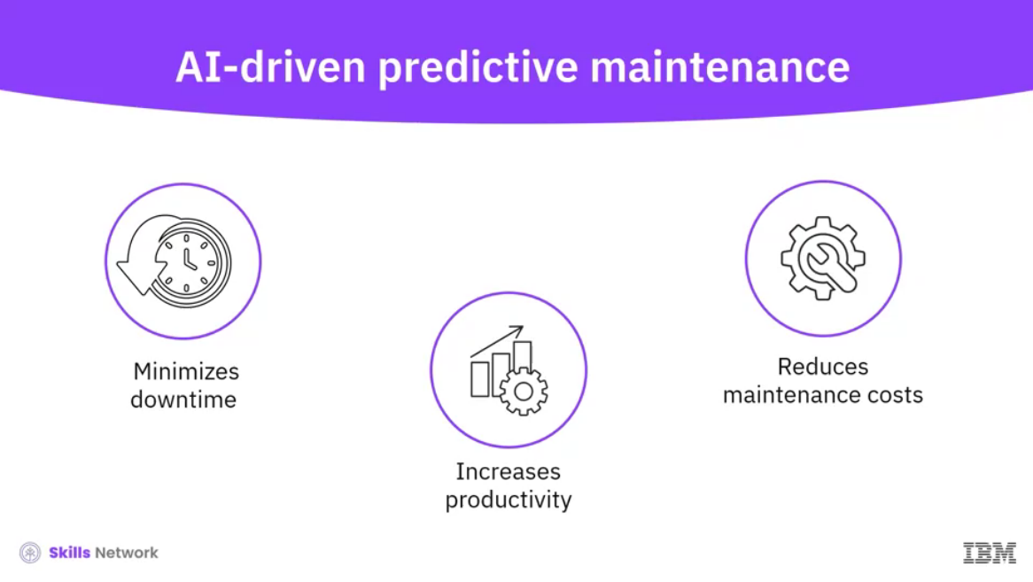  
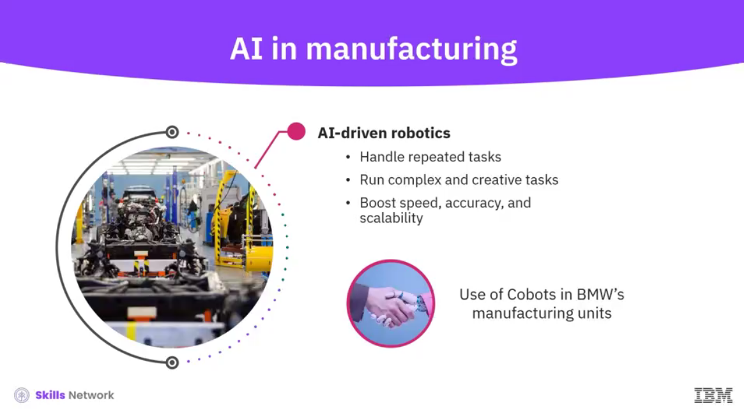

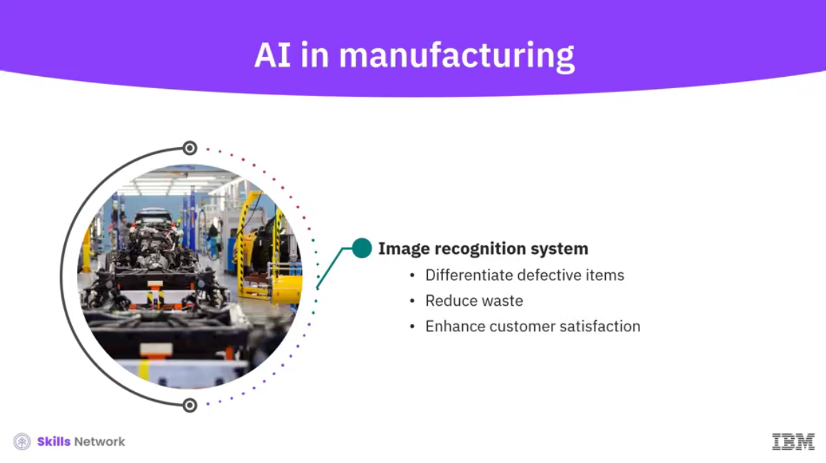

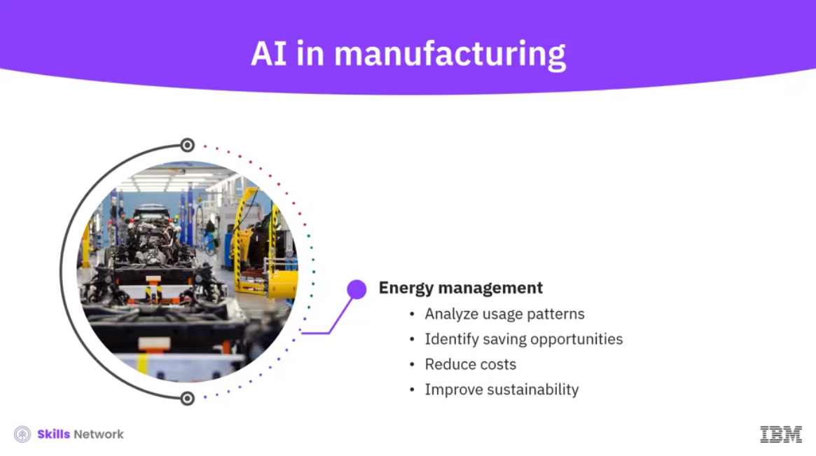

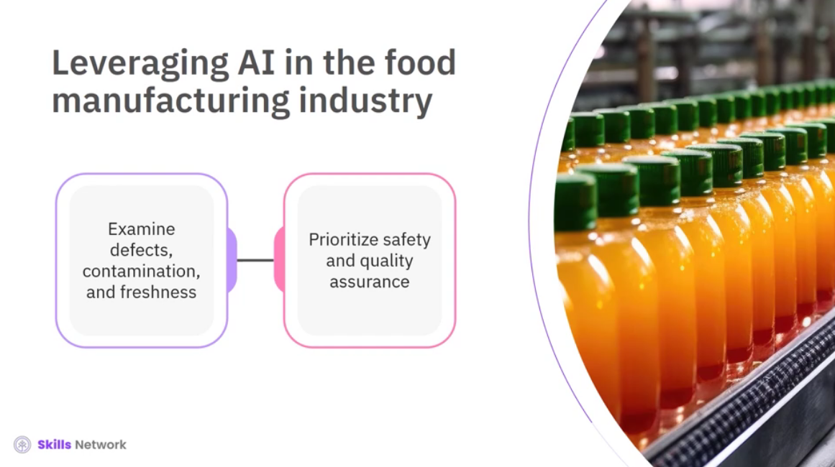

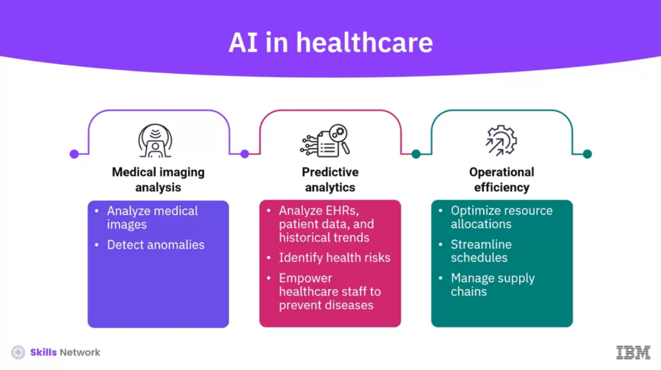

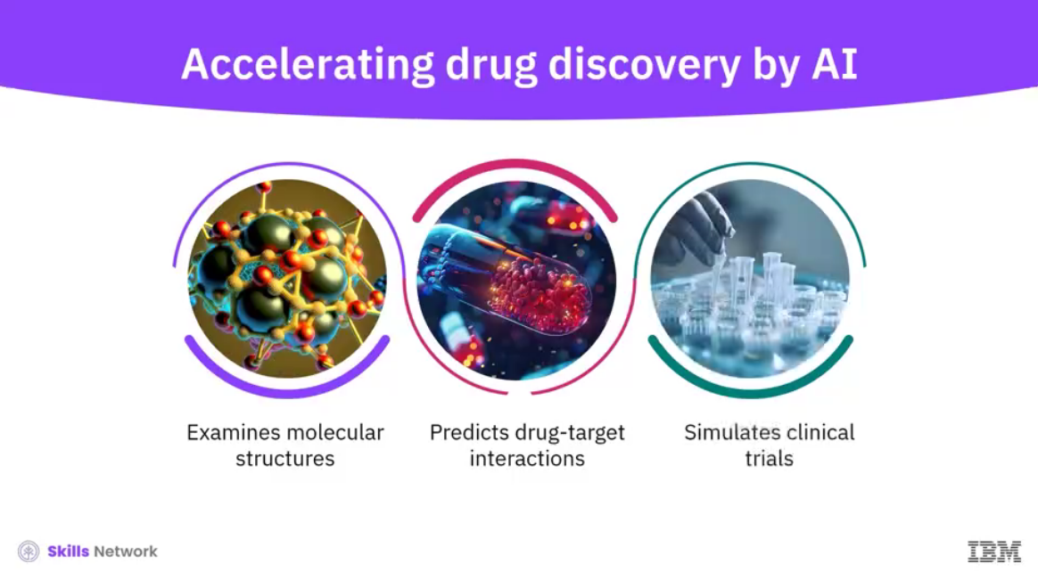

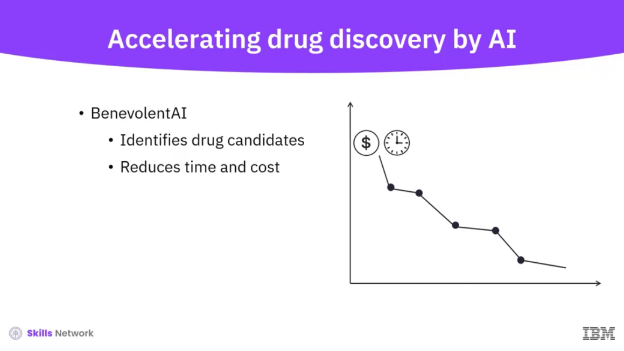

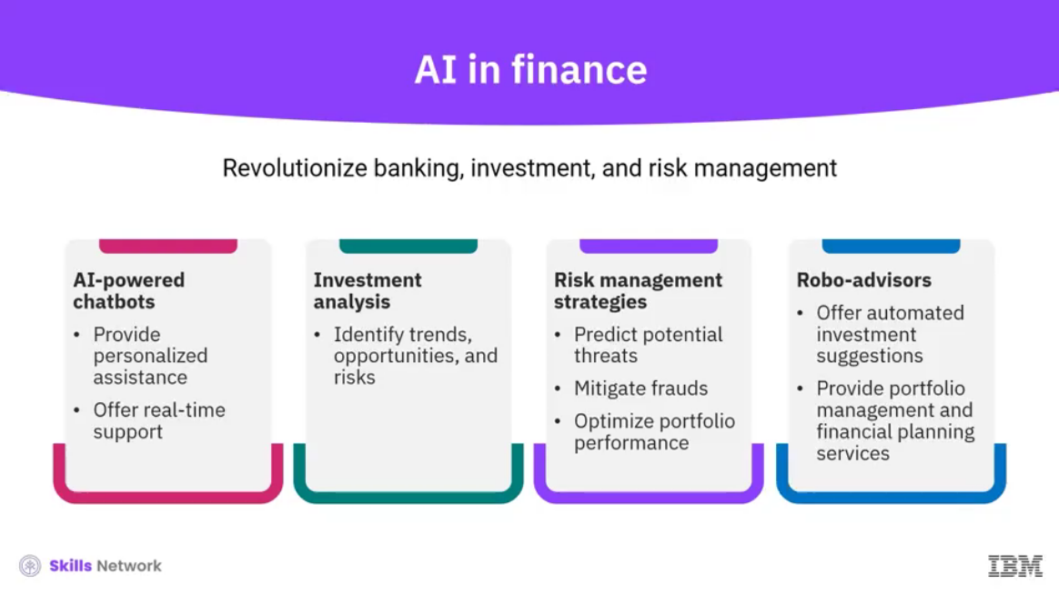

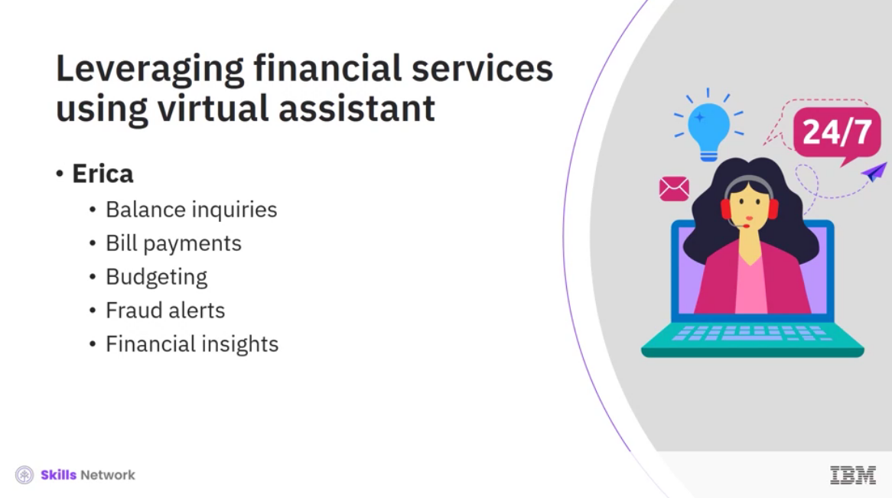

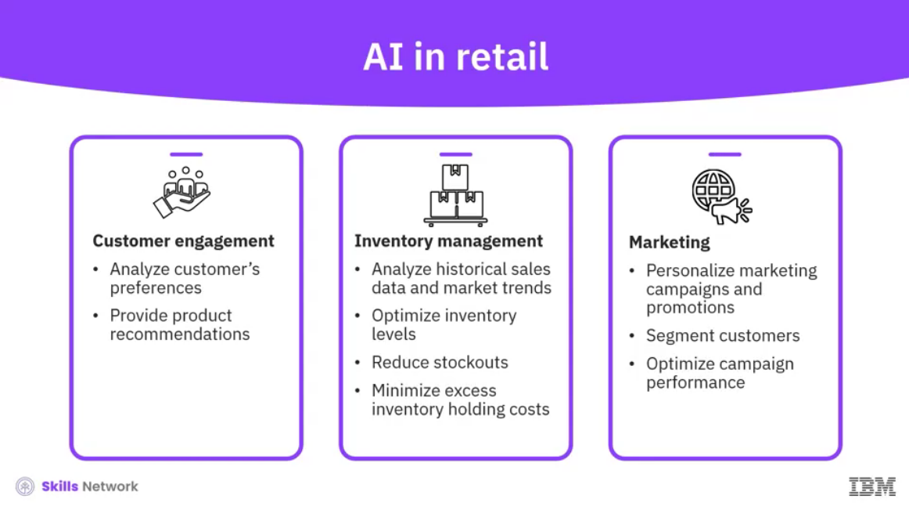

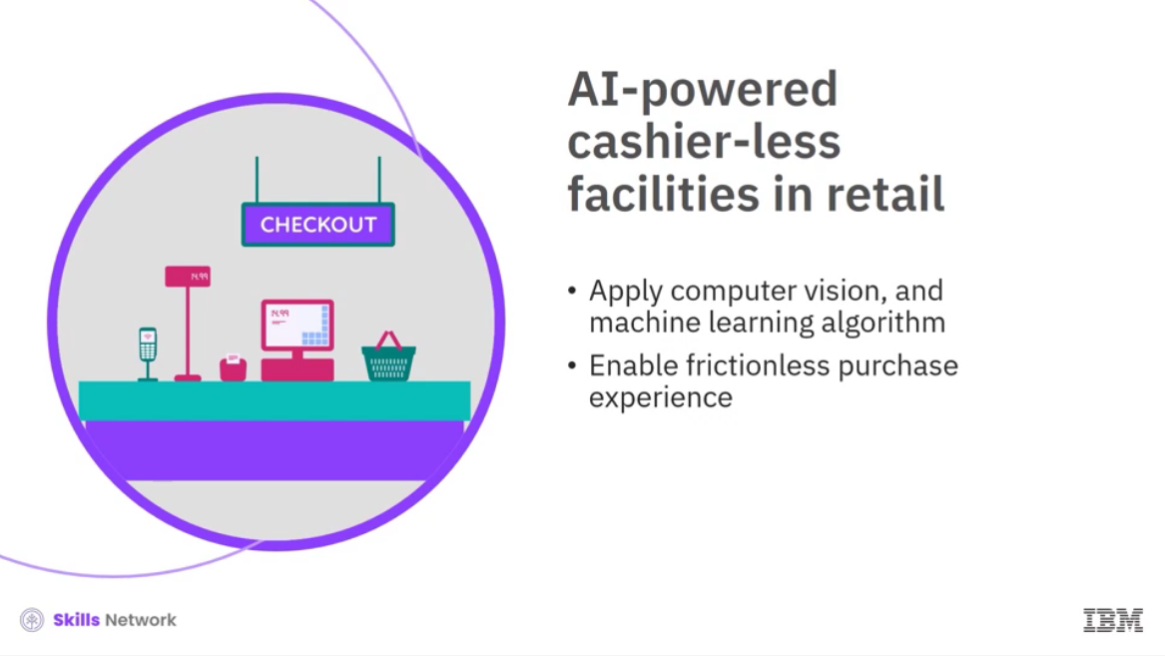

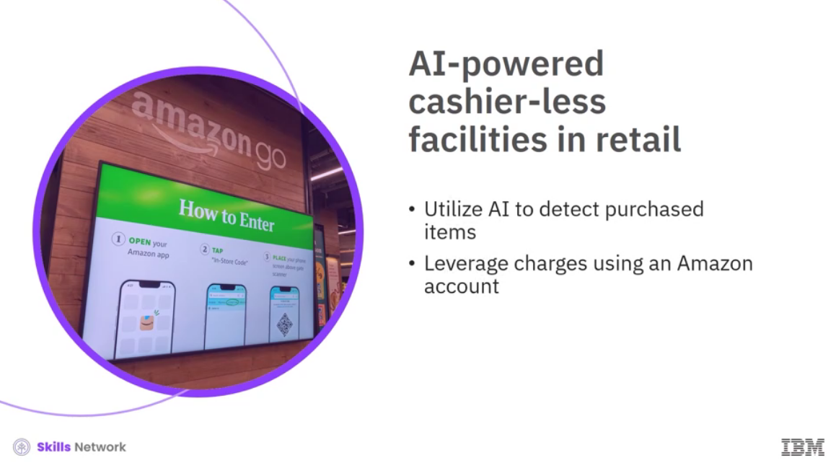

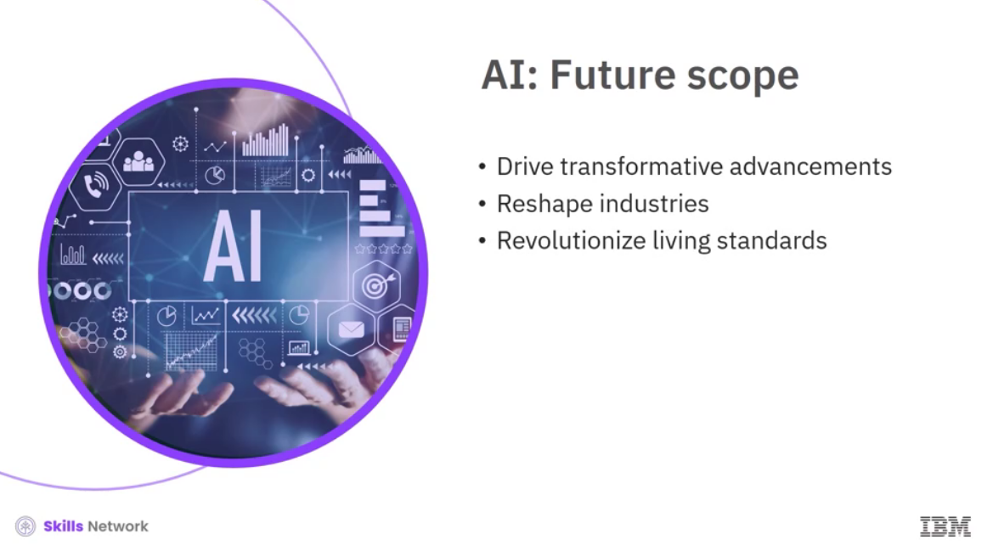

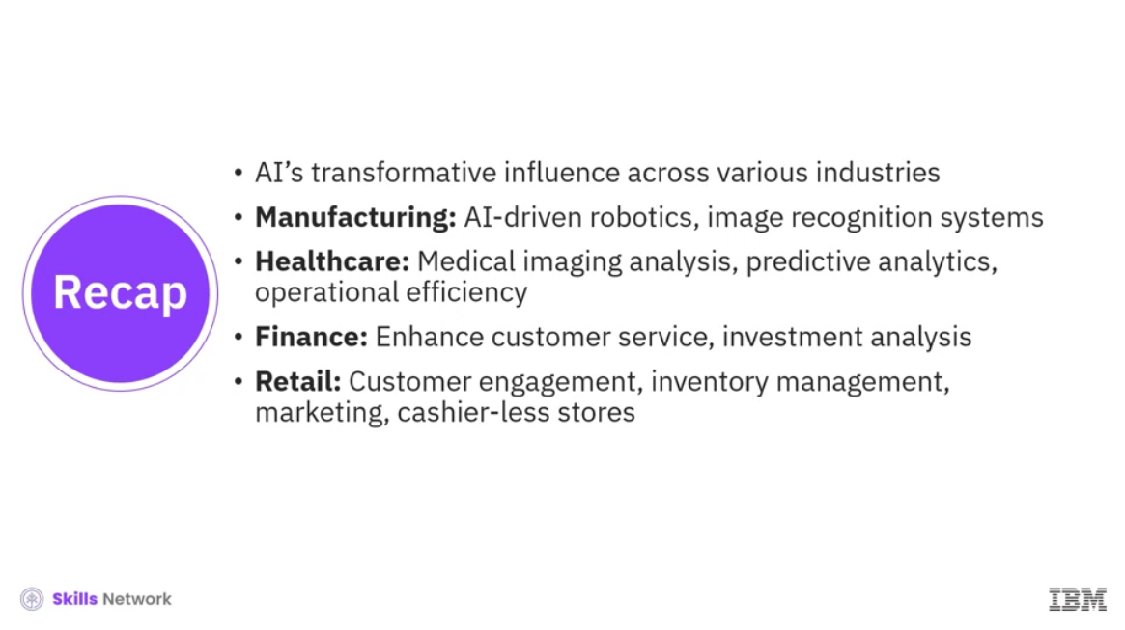

______________________________________________________________________________

**Ten Everyday AI and Machine Learning Use Cases**



